## CAVE – Calcium ActiVity Explorer

CAVE is a GUI programed in MATLAB and runs best with version R2016a and b (versions 9.0/9.1). It requires the following toolboxes: Image Processing Toolbox version 9.5, Signal Processing Toolbox version 7.3, and Statistics and Machine Learning Toolbox version 11. This GUI allows you to process calcium imaging videos recorded as TIFFs and at the same time the behaviour of the animal recorded as MP4.

*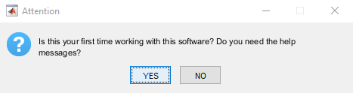*The first time you open the software you will be asked if you need help with the software. If you choose ‘Yes’, help messages will be displayed throughout the program to provide instructions. If you choose ‘No’, these help messages will be suppressed. Your choice will be saved in the Preferences file.

The next times you open the program it will remember your last choice. If you want to change the help settings at any given time, you can do so by selecting File → Preferences → Display help messages. A hook indicates that help messages are enabled, no hook that help messages are disabled.

#### Overview of the User Interface

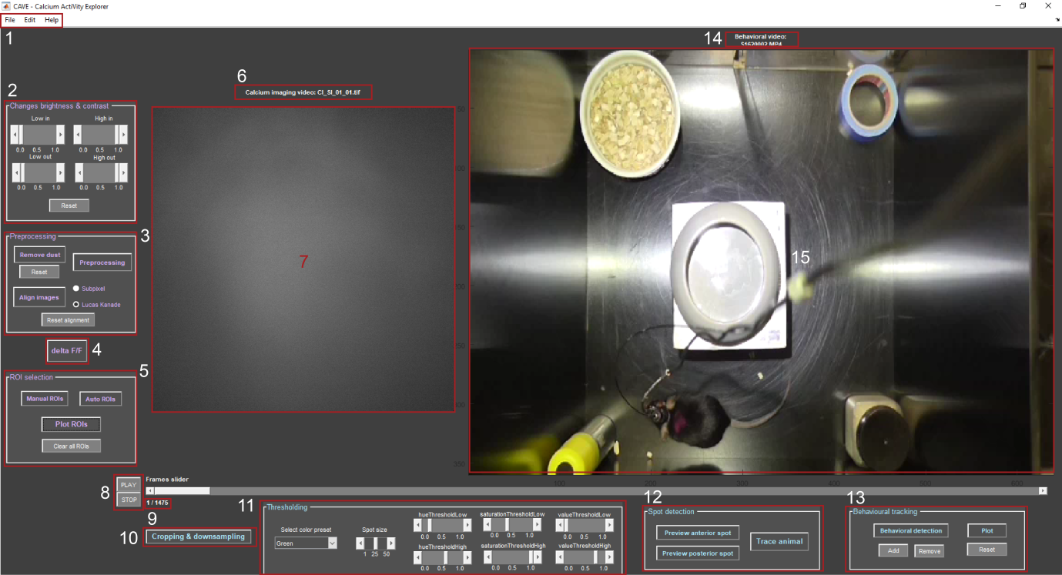

1: Menu bar containing File, Edit, and Help

2: Change brightness and contrast of the raw video

3: Process the video by down sampling, eliminating glitches, and performing flatfield correction; optionally remove dust or align images

4: Calculate the change of the video over time with deltaF/F

5: Find cells by manual ROI selection or automatic detection

6: Name of the current calcium imaging video

7: Calcium imaging video

8: Play and stop button to control playing of the video(s)

9: Showing current frame/total frames

10: Performs down sampling and cropping of the behavioural video

11: Define mask of one or two colour spots of the animal

12: Previews and saves one or both colourful spots of the animal with the specified mask, as well as traces location of the animal and correlates that with the cell activity found with the calcium imaging video

13: User defined behaviour detection

14: name of current behavioural video

15: behavioural video

## CONTENT

I Workflow to Process the Calcium Imaging Video

1. Loading Calcium Imaging Video
2. Optional: Remove Dust
3. Pre-processing
4. Optional: Image Alignment
5. Delta F/F Calculation
6. Cell Detection/ ROI Selection
7. Calculating and Plotting Calcium Transients
8. Optional: Save Video
9. Importing Trigger

II Workflow to Process the Behavioural Video

1. Loading Behavioural Video
2. Crop and Down Sample Video
3. Optional: Define Mask for Tracking Animal
4. Optional: Preview and Save Tracking
5. Optional: Plot Locations Correlating with Cell Activity
6. Behavioural Detection

III Advanced

1. Setting Parameters

IV Troubleshooting

## I Workflow to Process the Calcium Imaging Video

#### C:\Users\Asspen\Documents\PhD\MatlabGUI\help\overviewvidS1_01.pngLoading Calcium Imaging Video

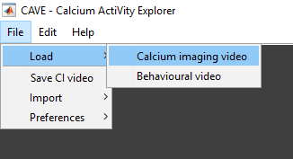First select the folder where your calcium imaging video is located by selecting File → Load → Calcium imaging video (1).

Please have only one TIFF stack or series per folder. You can provide a simple text file with a number describing the frame rate in the same folder. If a text file is not present, you will be asked for the frame rate manually.

*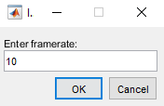*

When the video is loaded, you can adjust the brightness and contrast by changing the values for ‘High in’, ‘High out’, ‘Low in’, and ‘Low out’ (2).

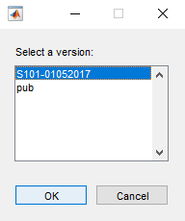In case you already worked with this video before, you will be asked if you want to load your last version (below). By choosing ‘Yes’ your lastly saved progress will be loaded, by choosing ‘No’ the program will load the raw video. In case you have multiple versions, a list will appear, from which you can select the version you want to load.

In case the video file is bigger than 4500 frames, the program will automatically downsample and preprocess the video in order to load it. In this case you will already be asked if you wish to remove dust from the video (see 2. Optional: Remove Dust).

#### C:\Users\Asspen\Documents\PhD\MatlabGUI\help\overviewvidS1_02.pngOptional: Remove Dust

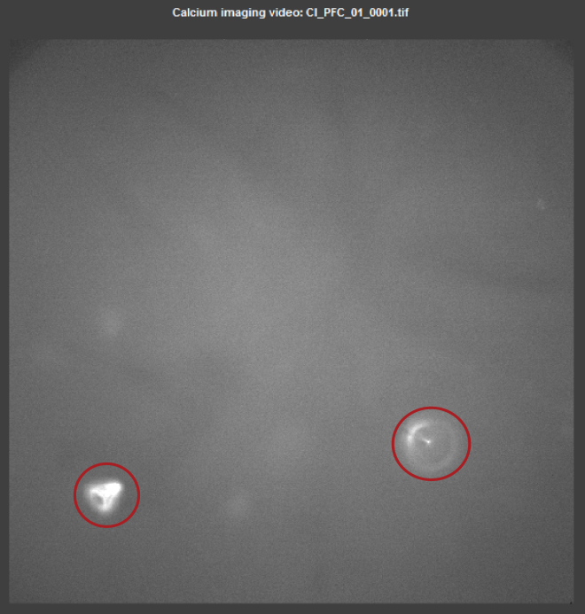You can remove dust or other static irregularities (circled in red) from your video by pressing ‘Remove dust’ (3).

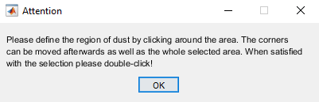The pop-up explains how to select the area (above). You click around the area of interest and once you are finished, double-click (below).

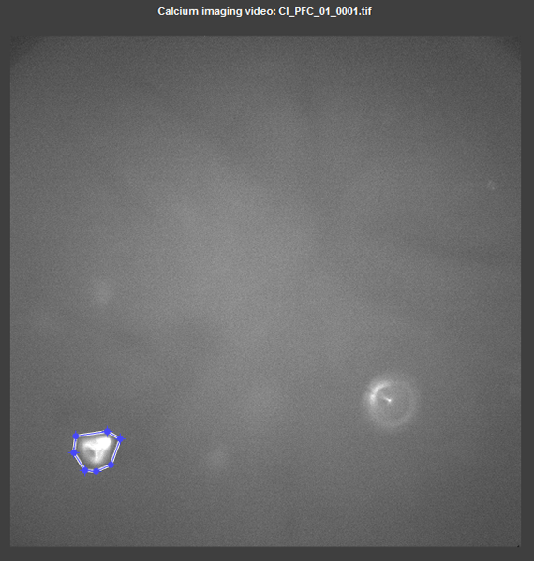The code will fill the area with a mean value of the neighbouring pixels (below).

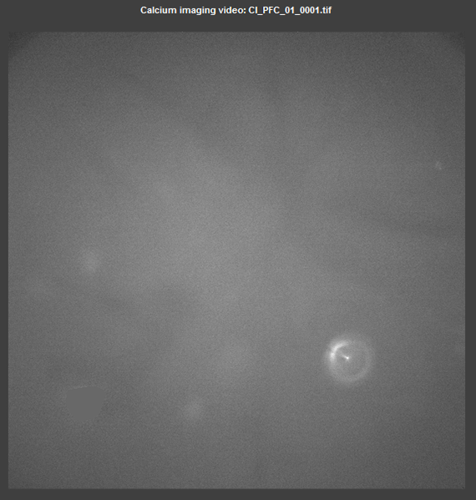

#### C:\Users\Asspen\Documents\PhD\MatlabGUI\help\overviewvidS1_03.pngPre-processing

Before the actual process starts, you will be asked to name the current session (for example: animal-date like Animal01-01202017). This name is important for later re-loading the data to resume where you left off or if you process the same video multiple times, you can use it to distinguish between the different versions. The name(s) are saved as **name**.mat in your origin folder. This name is further referred to as **yourfilename**.

The first step of pre-processing (3) involves down sampling the calcium imaging video to 40% of the original resolution. Next the video is searched for dropped frames, e.g. completely black frames. Those frames are substituted by the previous frame. Lastly, the video is corrected for the brightness gradient (darker at the edges, lighter in the middle) by simplified flat field correction. This correction divides every image by an averaged blurred image of the video and multiplies it with the average value of the whole video. Additionally it cuts out the middle 80% of the video such that the darker borders are discarded (exemplary result is shown below).

*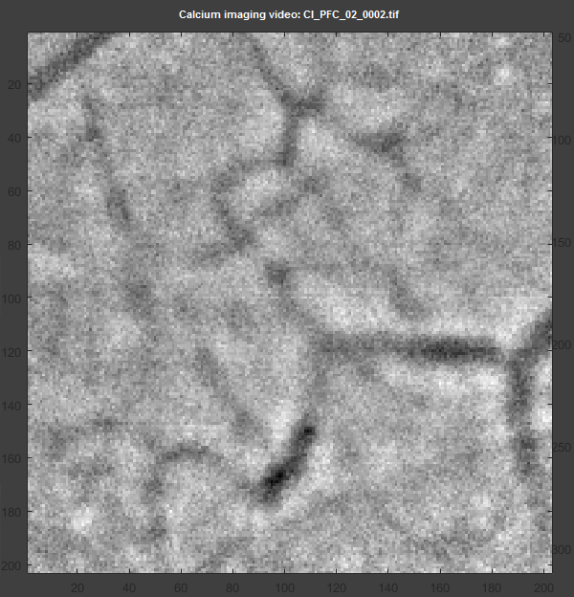*

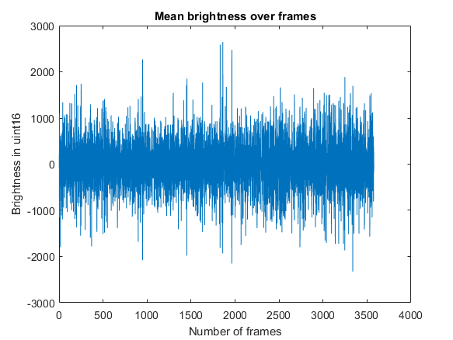Pre-processing gives out a graph showing the mean brightness over time (above). This is to see, if there are any major changes in global brightness, either due to photo bleaching or other events. This graph is saved in your origin folder as **Mean Change**.PNG.

#### Optional: Image Alignment

*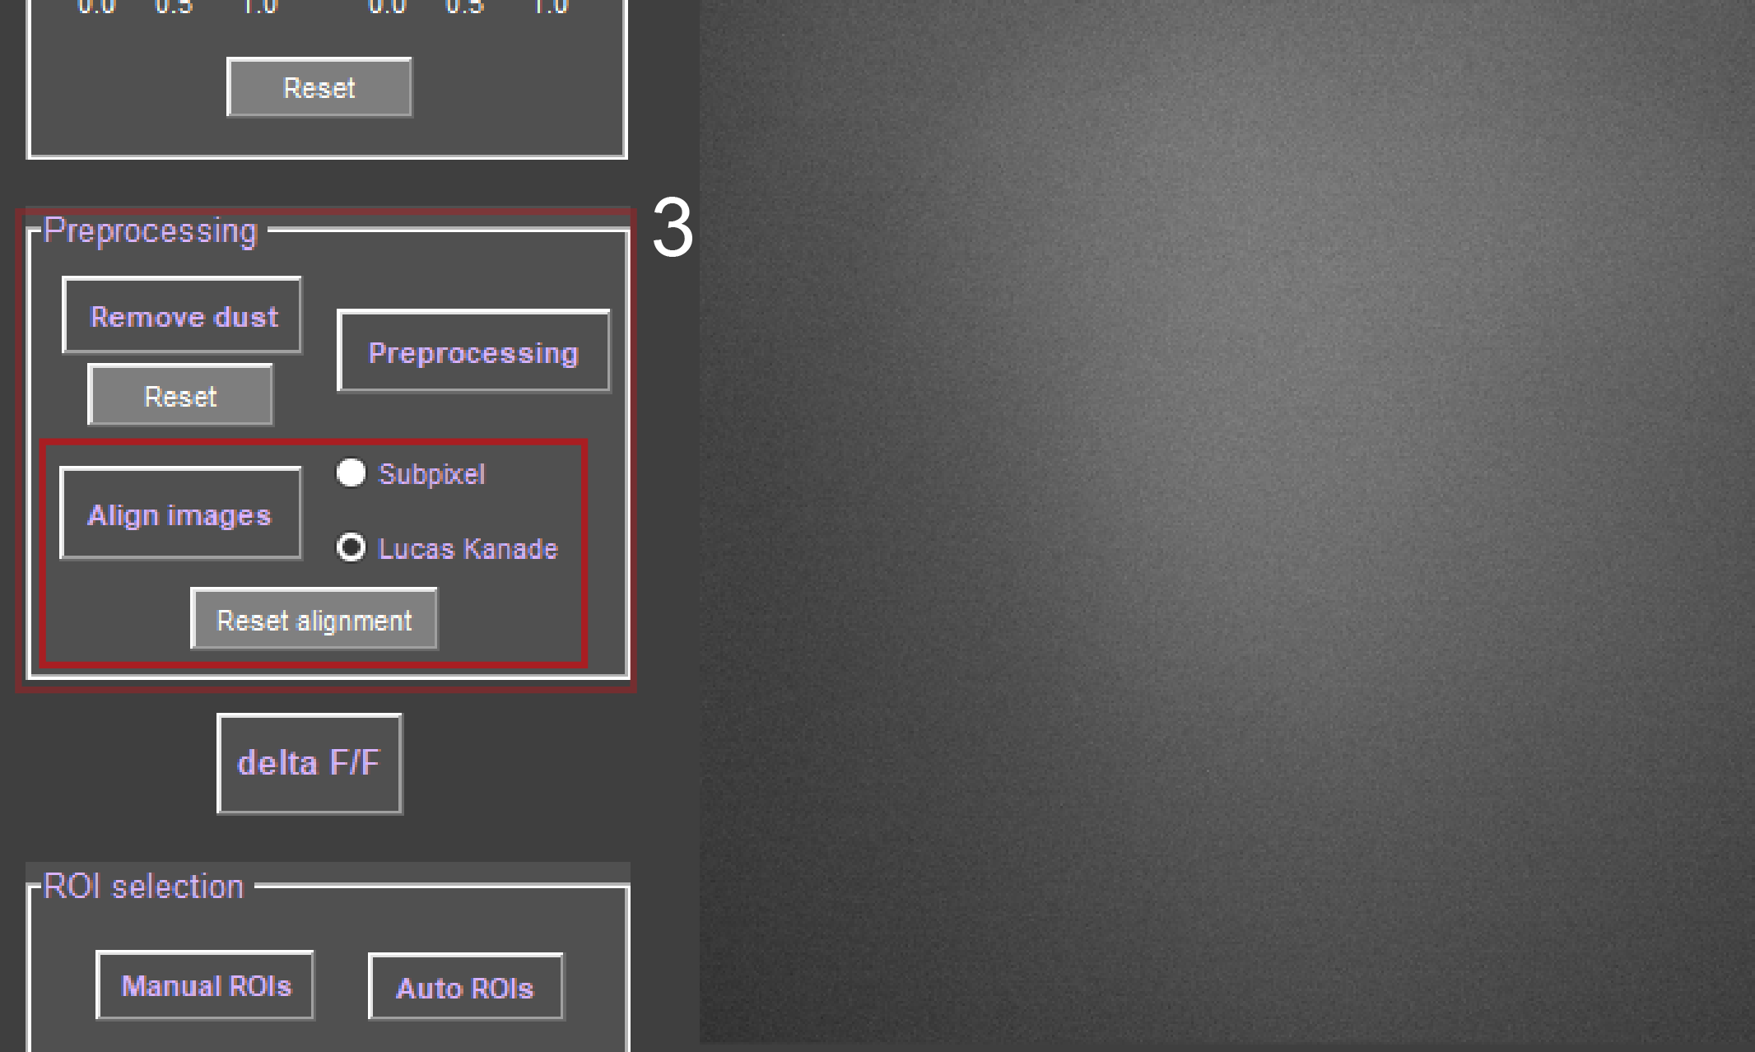*

If your video is shaky, you have the option to align the images with two different algorithms: the sub-pixel image registration or the Lucas Kanade algorithm (3). Select either the ‘Subpixel’ or the ‘Lucas Kanade’ radio button and press ‘Align images’. You will be asked whether you would like to align the images to the ‘Previous frame’ or to an ‘Area’. When selecting ‘Previous frame’ the frames will be corrected to the whole first image and each subsequent image to the previous corrected image. This option is best selected if no distinct features are visible but active cells are visible over time. By selecting ‘Area’ you define a ROI. The ROI should contain some distinct features like blood vessels (see below).

*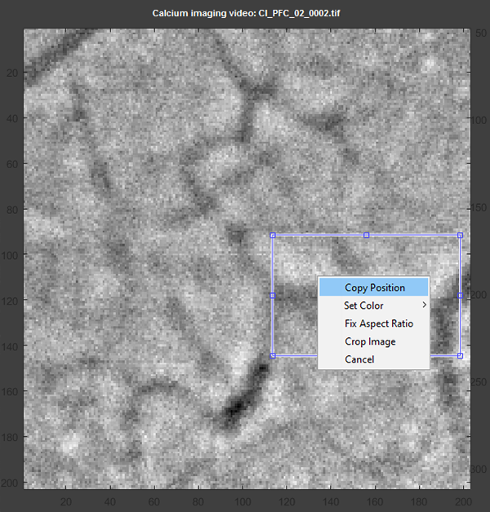*

Once the area is selected, right-click, select ‘Copy position’, and follow the import wizard by clicking ‘Next’ and ‘Finish’ (below). The import wizard imports the coordinates of the defined ROI.

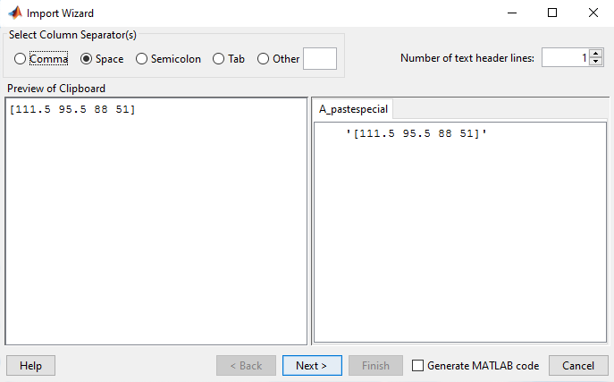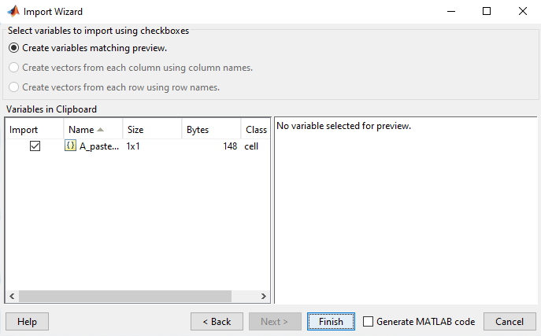

The ROI is enhanced by maximizing contrast, sharpening, and noise filtering, to have best possible distinction of the features in the image (e.g., the blood vessels). This processed ROI is then further used by one of the two alignment algorithms:

Lucas Kanade: It computes the geometric transformation that is applied to match one image to another. The optimal transformation is the one that minimizes the squared image difference between both images. The transformation vector that is found aligning the ROI is then used on the whole video. It is best suited to match videos containing distinct static features.

*Subpixel*: It computes a discrete Fourier transform matrix to cross-correlate two pictures. It can correlate within a fracture of pixels (1/100).

After alignment the program uses the biggest shift in every direction to crop out the middle part such that no alignment artefacts at the border are visible.

To reset alignment use the respective button. As soon as you resume to the next step, the delta F/F calculation it is assumed that you are satisfied with the alignment and it cannot be reset afterwards.

#### Delta F/F Calculation

*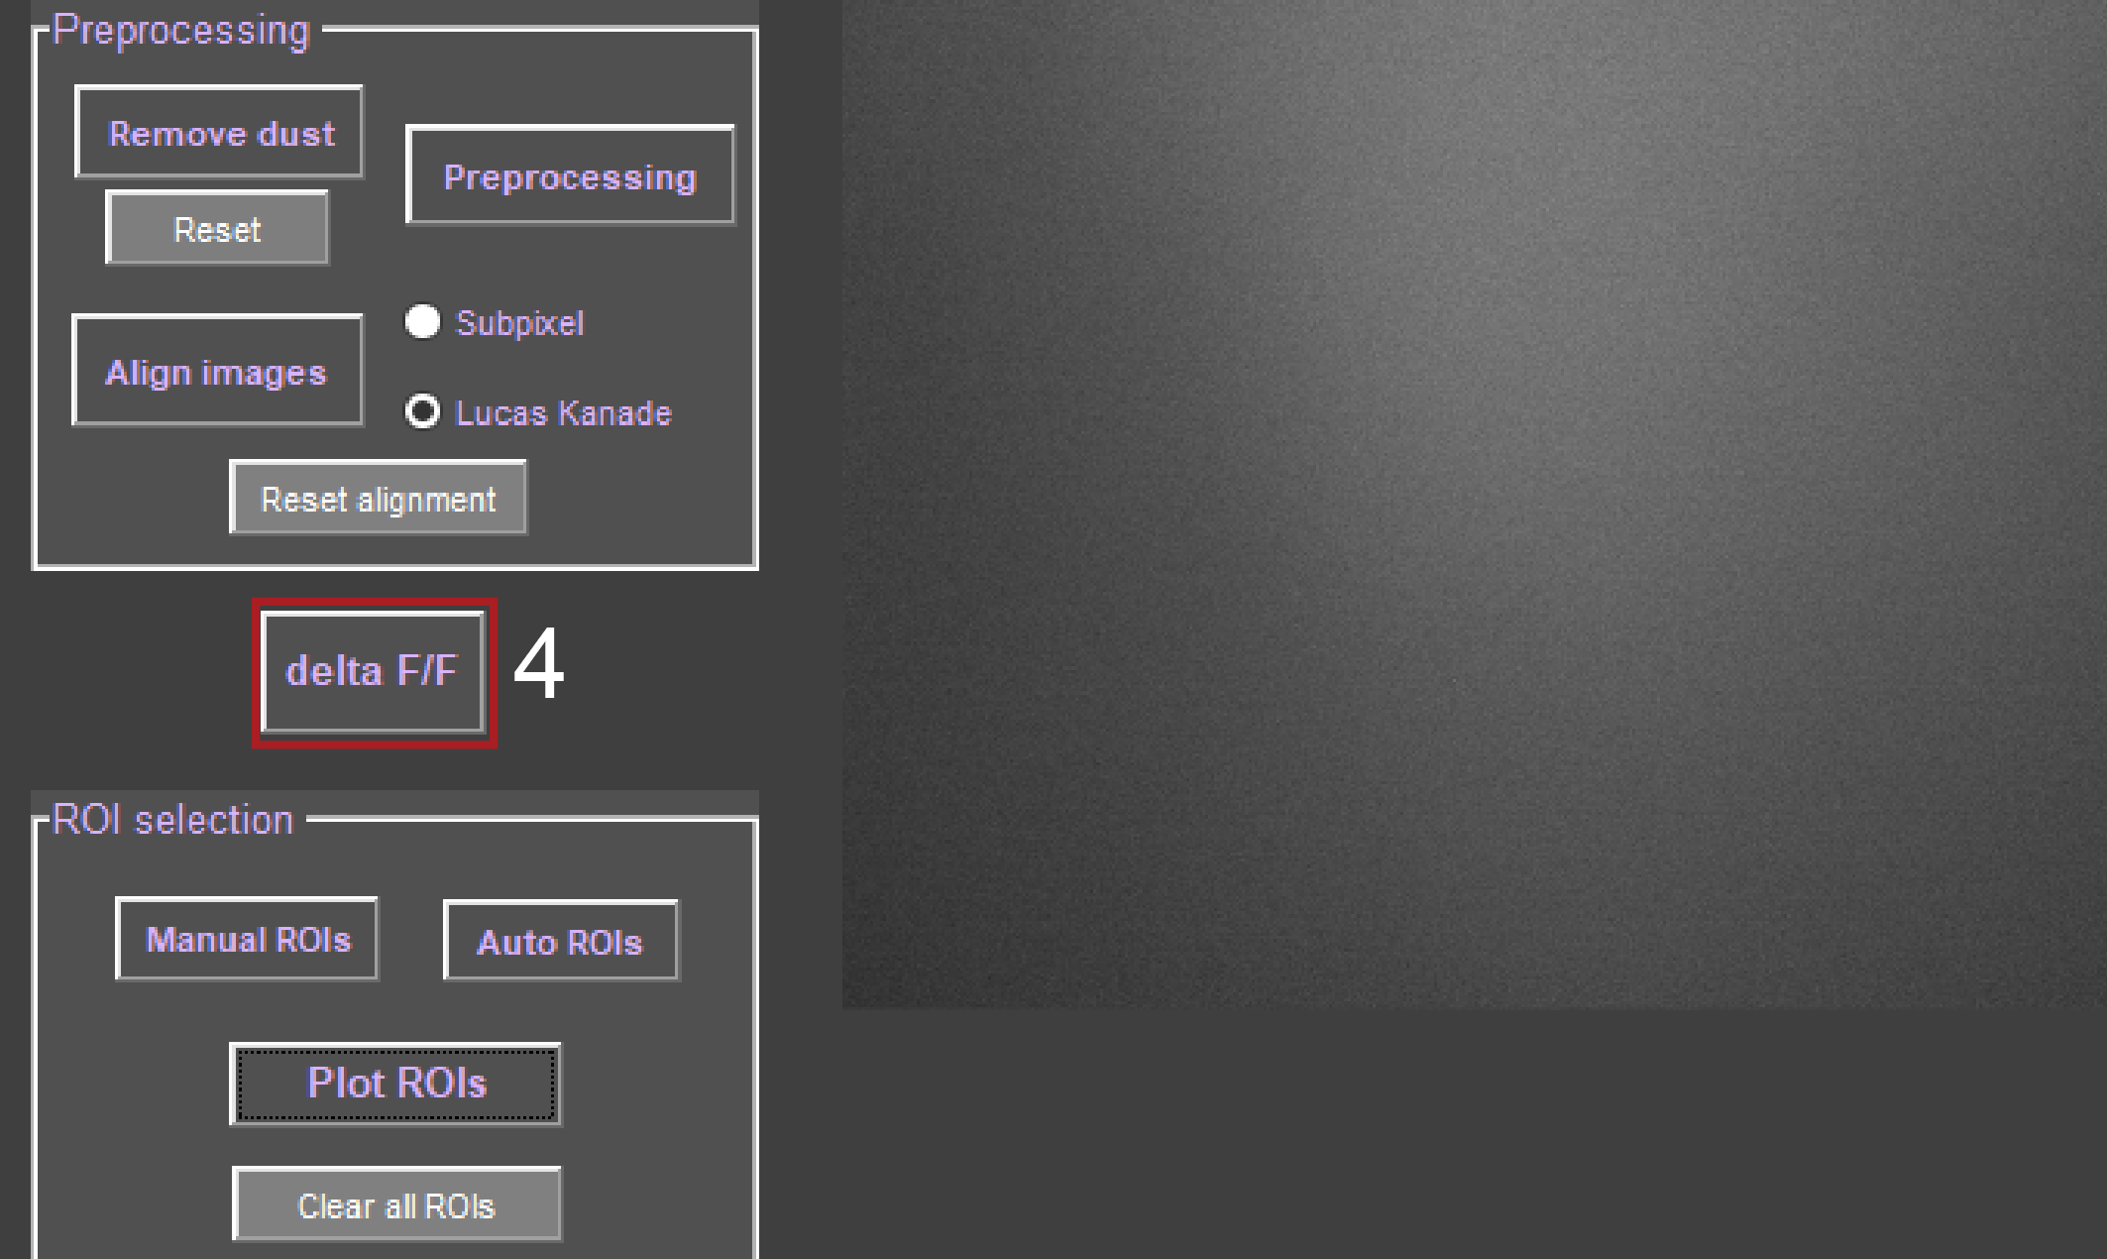*

In order to measure the fluorescence change of cells over time, the ∆F/F method is most commonly used (4). This method uses the mean of all video frames and first subtracts the mean frame from each individual video frame, then divides the result by the mean frame:

$$\frac{∆F}{F}= \frac{{frame}_{i}-mean(video)}{mean(video)}$$

Additionally, we use a Gaussian blur on the whole video, result can be seen below. Notice that blood vessels are almost invisible, and a bright cell is visible in the upper middle.

*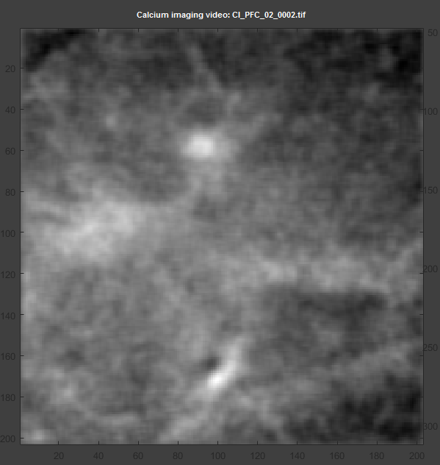*

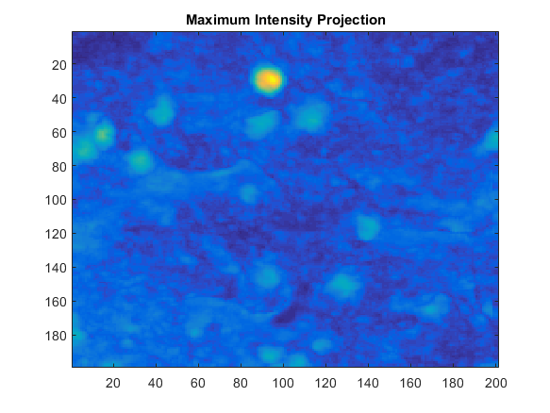The image above is saved in your origin folder (**yourfilename**\_MIP.mat) and shows the maximum intensity projection of the whole ∆F/F processed video divided by the standard deviation of the whole ∆F/F video. In this image you can see cells in bright yellow and blood vessels are almost invisible, since they are static. This image shows only the sum of changes in brightness over time. Note that minuscule or rare changes in fluorescence will not appear in this image. The image only offers an estimation of active cells.

Furthermore your progress is saved at this point, so that if you want to load the same video again, you can continue where you left of. The ∆F/F video is saved as a MAT-file (**yourfilename**dFvid.mat) and whether the video has been aligned is saved as a variable (**yourfilename**vidalign.mat).

#### Cell Detection/ ROI Selection

*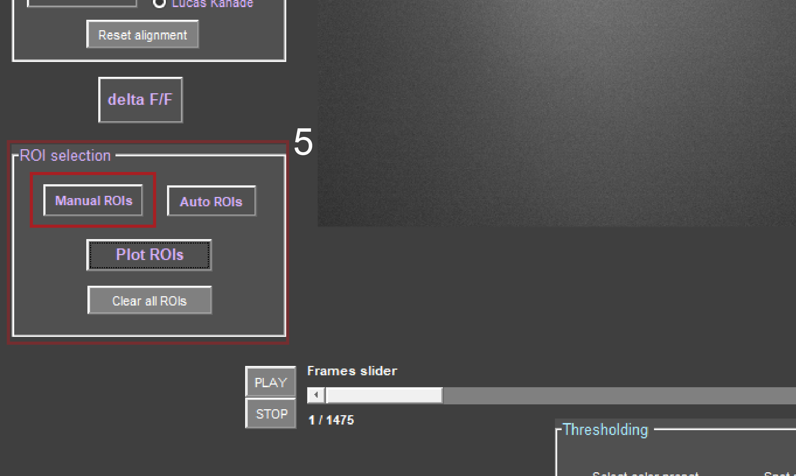*

Manual ROI selection:

*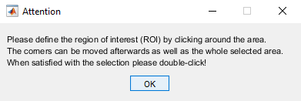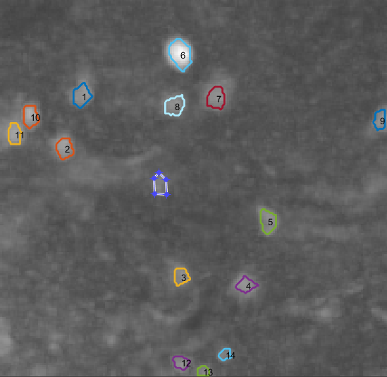*To manually identify cells press ‘Manual ROIs’ (5) and you will see the maximum intensity projection image as background. Then you can choose a desired area by clicking around it, like the pop-up instructions below suggest.

Selecting a ROI.

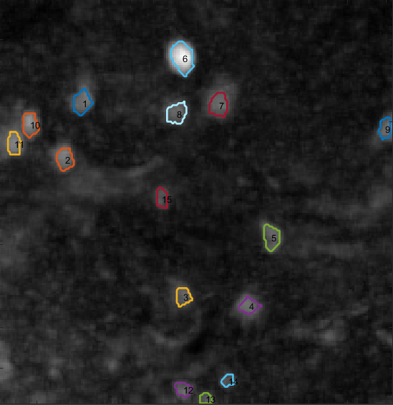

New ROI number 15 added to the ROI mask.

When selecting ROIs manually your progress with the ROI mask will be saved automatically. This setting can be changed in Preferences (see below). If you remove the hook, you will be asked to save the ROI mask every time you remove or overlap ROIs.

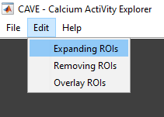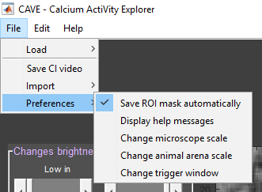You can alter ROIs in three different ways by overlapping with a new ROI: expansion, removal or overlay. If you overlap a ROI you will be asked every time which of the three options you wish to do, unless you choose a default action from Edit.

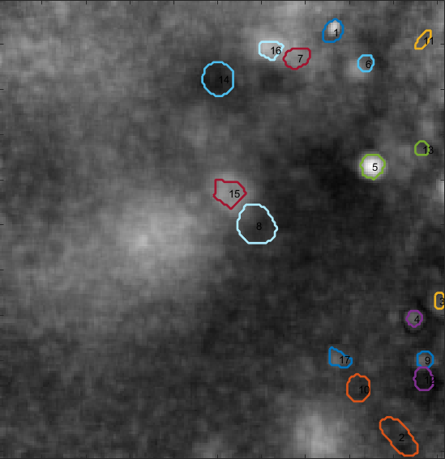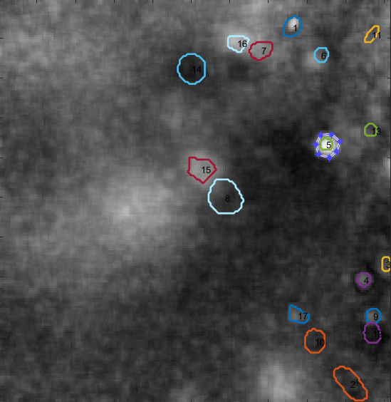When choosing expansion, you can expand ROIs to make them bigger.

Result of expanding ROI 5.

Expanding ROI 5.

When choosing removal you can remove parts of a ROI but also entire ROIs by overlapping. Note that when you remove a ROI, the labelling of the ROIs changes and the numbers shift.

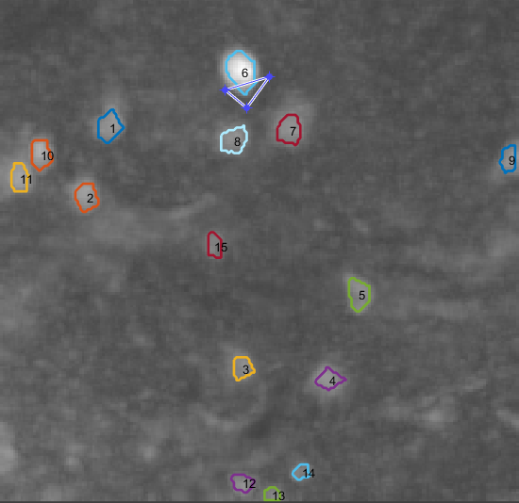

Removing a part of ROI number 6.

Result of removing part of ROI 6.

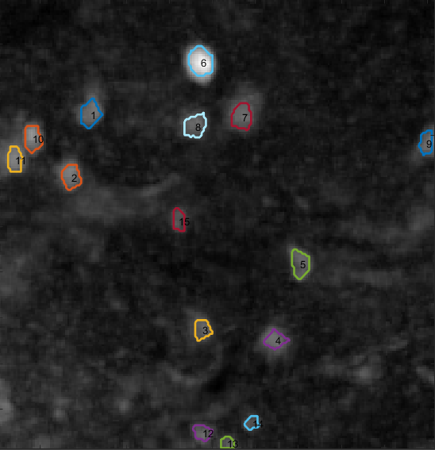

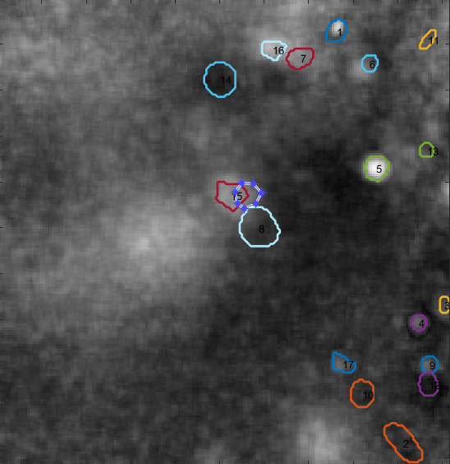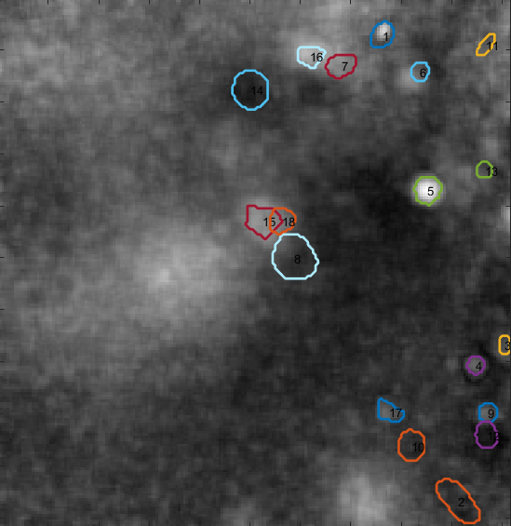When choosing overlay, you can generate entire new ROIs on top of already existing ones.

Removing the entire ROI number 5.

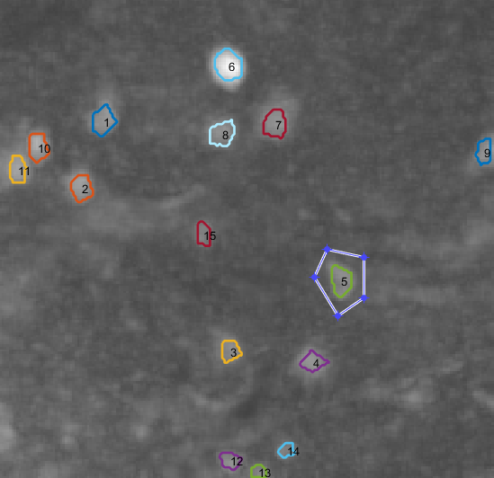

Result of removing ROI number 5. All ROIs above 4 have been re-labelled and shifted in numbering by -1.

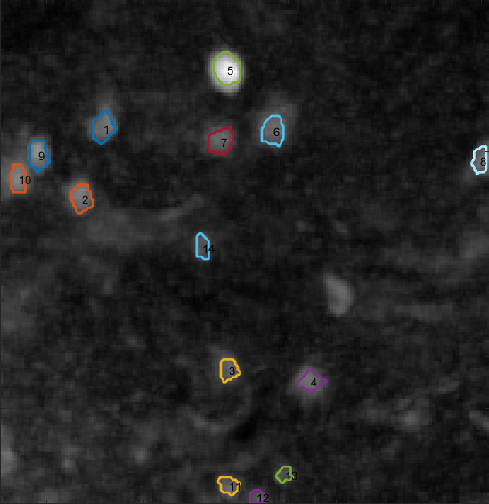

Result of overlaying ROI 15. ROI 18 is the new overlaid ROI.

Overlaying ROI 15.

If you wish to import a ROI mask from a previous session or another version, you can do so by going to File → Import → Cell ROIs. The file containing the mask has the following structure: **yourfilename**ROIs.mat. This is the same file that will be loaded in case you are re-opening the video and are asked if you want to load your last processed version.

You can clear the whole mask any time by pushing ‘Clear all ROIs’.

*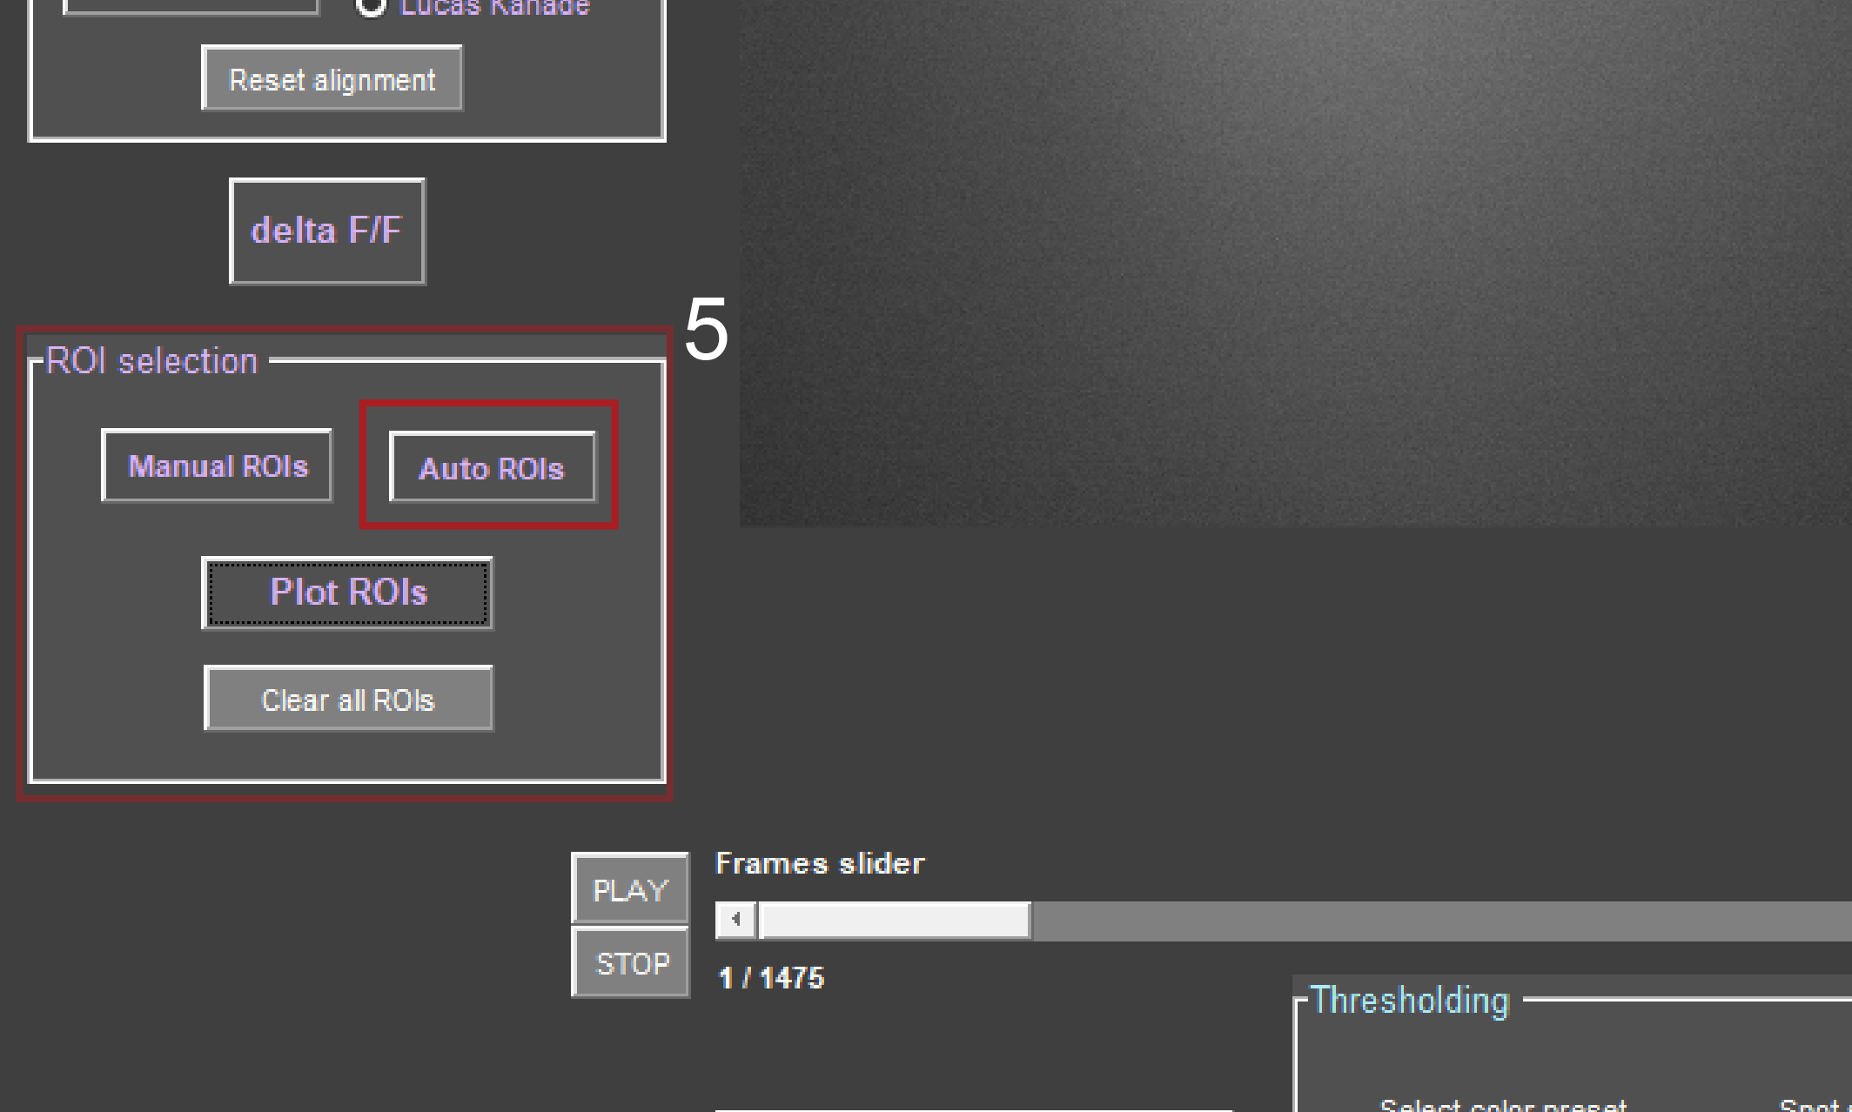*

Automatic cell detection:

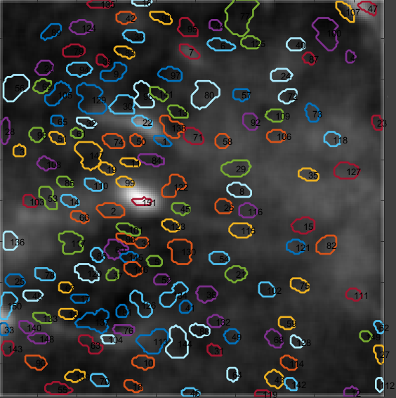Press ‘Auto ROIs’ (5) for automatic cell detection, which is recommended in case of many active cells. The automatic cell detection uses principal component analysis (PCA) to find components and order them according to the highest variance. You are asked for the approximate cell number, which you can estimate from the maximum intensity projection. The number should always be slightly overestimated and is utilized to reduce the dimensions resulting from the PCA and in the next step to find the actual cells with the independent component analysis (ICA). The ICA finds the independent components from the PCA components. The result should be a number of single cells.

151 cells found with automatic cell detection.

To reduce artefacts, ROIs above an area of 300 square pixels are excluded, as well as non-round objects at a threshold of 0.6. Double assignments are excluded by comparing overlap of the found components. At the same time, ROIs that have an overlap greater than 30% will be interpreted as one ROI. These settings can be adapted in the SetParams.mat Matlab-Skript in the CAVE folder (How to in XXX).

After automatic ROI detection it is recommended to control the result and alter the mask by removing or adding ROIs like described above. Alternatively, you can also push ‘Auto ROIs‘ again and re-estimate the number of cells. This process will be faster than before, since the progress of the PCA is saved to your origin folder (**yourfilename**PCA.mat).

#### C:\Users\Asspen\Documents\PhD\MatlabGUI\help\overviewvidS1_08.pngCalculating and Plotting Calcium Transients

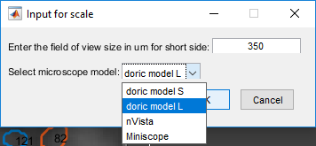After selecting the cells from the video, you can plot the calcium traces by pressing ‘Plot ROIs’ (5). First you will need to enter the microscope model you are using or alternatively the length of the video in µm.

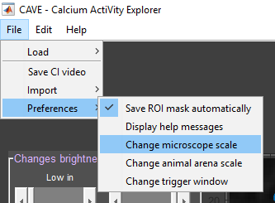The value you enter will be saved in Preferences and will be assumed for all future sessions. Should the microscope model change, you can adapt the new value in File → Preferences → Change microscope scale.

This scaling value is used to translate pixel to µm in order to estimate the surrounding neuropil of the cells. The average value of the surrounding neuropil is then subtracting from the average value of each corresponding cell to estimate fluorescence changes. Afterwards some ROIs are merged if ROIs in close vicinity to eachother have a bigger correlation than 0.8 or deleted if the absolute fluorescence change is smaller than 0.8. The resulting values are de-trended to remove global trends and saved as a MAT-file in your origin folder (**yourfilename**\_ROIvalues.mat).

Next the results are deconvoluted to estimate the underlying calcium transients. The deconvolution algorithm used utilizes the Online Active Set method to Infer Spikes (OASIS) algorithm with a deconvolution kernel assuming the auto-regressive model with order 2. Afterwards spike values below a threshold of two times standard deviation are discarded. The results are rounded up. The deconvoluted signal is saved as MAT-file in your origin folder (**yourfilename**CaSignal.mat).

*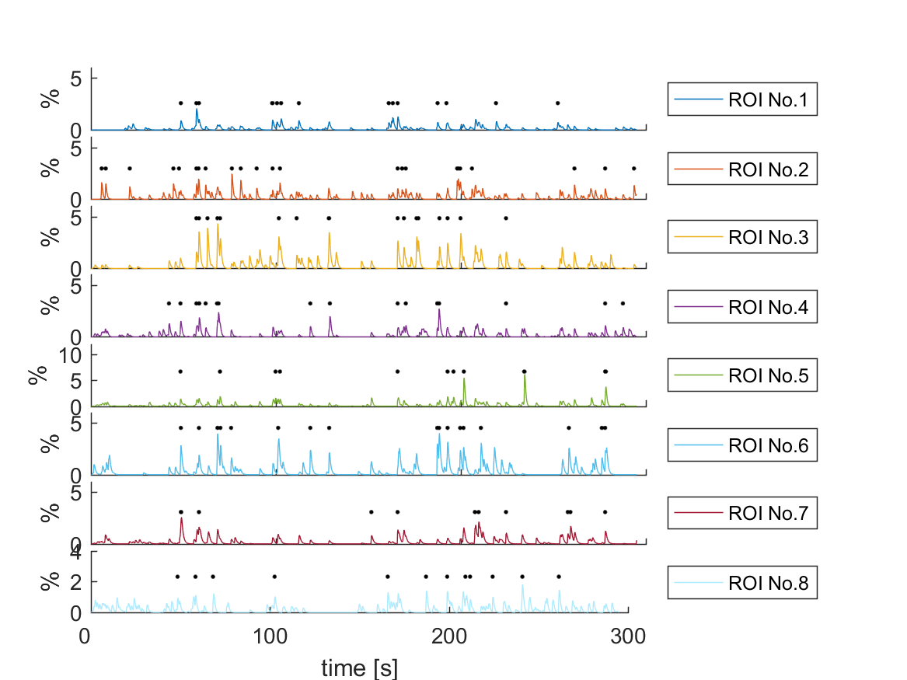*If you agree to save the calcium traces, a folder named traces will be created in your origin folder. This folder will contain the following: PNGs of the resulting calcium transients with 8 ROIs per figure in different colours and with black dots over detected calcium spikes (**yourfilename**\_traces\_**number**.png); a raster plot summarizing all spiking activity (**yourfilename**\_rasterplot.png); a heat map of the un-deconvoluted raw ROI values (**yourfilename**\_Fluo.png); an image of the ROI mask you used (**yourfilename**\_ROImask.png); an EXCEL-file with stats of the ROIs (total number of spikes, total spiking frequency, and maximum amplitude which is not rounded) (ROIs\_**yourfilename**.xls); a structure array containing the frame rate of the video, the raw wave forms of the ROIs, the deconvoluted wave forms, and the detected spikes with timestamps and amplitude(traces\_**yourfilename**.mat).

traces\_1.png

*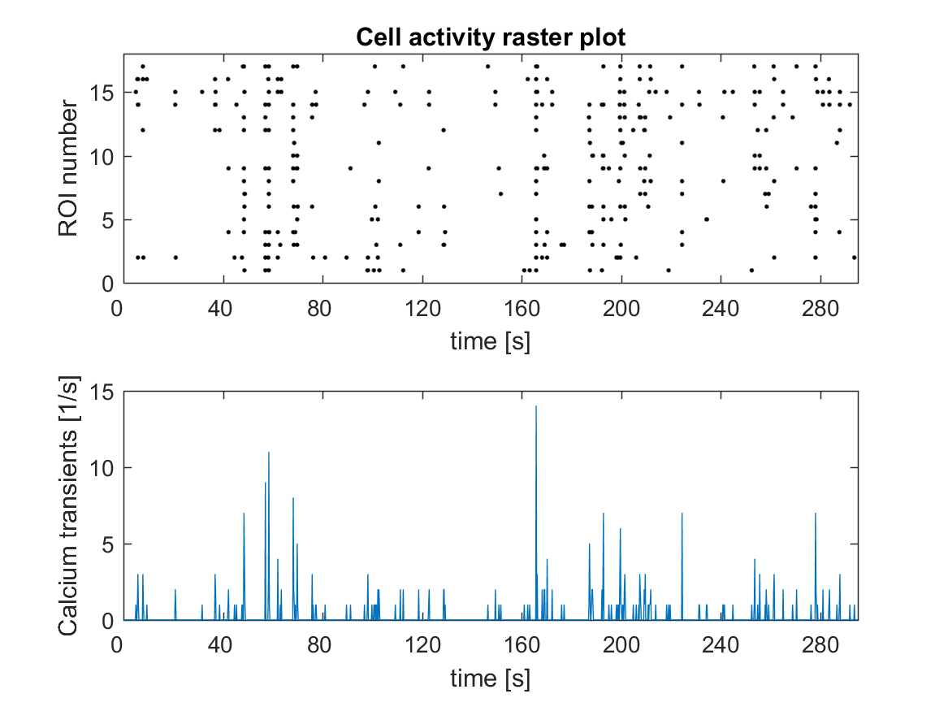*

rasterplot.png

*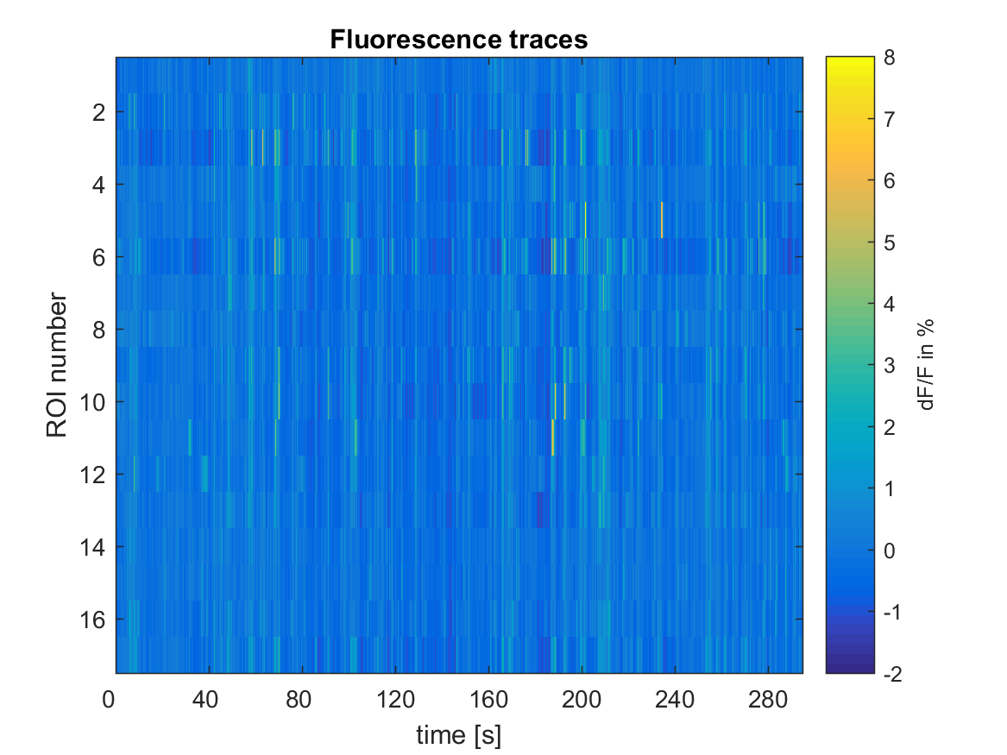*

Fluo.png

*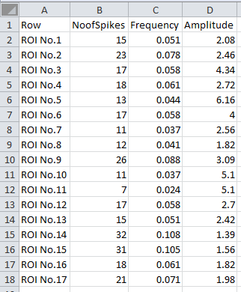*

ROIs.xls

Once you completed the behavioural detection (II 6.), you can plot the tracked behaviour in the plots you saved before. Each colour bar stands for a certain behaviour that you defined during the behavioural detection. The colour code can be looked up in the **yourfilename**animal\_behavior.png image in your origin folder. All the following files are saved in the traces folder: PNGs of the calcium transients with the behaviour (**yourfilename**\_traces\_behav\_**number**.png); a raster plot summarizing all spiking activity with behaviour (**yourfilename**\_rasterplot\_behav.png); an average deconvoluted calcium signal over time (**yourfilename**\_ meanFluobehav.png); an average event rate of detected calcium spikes (**yourfilename**\_ meanspksbehav.png); an EXCEL-file with average event rate of calcium spikes for each behaviour (freqbehav\_**yourfilename**.xls); and optionally heat maps of the behaviours triggered to the onset of the behaviour with a normalized activity plot (**yourfilename**\_Fluotrigbehav\_**number**.png) and a MAT-file containing the event rate of calcium spikes for each repetition of each behaviour (freqbehavrep\_**yourfilename**.mat).

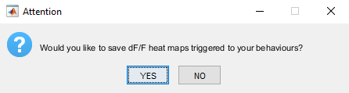If you have defined behaviours and you did not load any trigger files you will be asked whether you want to plot heat maps triggered to the onset of your behaviours (see below).

If you choose ‘Yes’ you have to define a window size for the plot. You have to type in two numbers: first, the amount of time you want to observe before the onset of the behaviour, and second, the amount of time you want to observe after the onset of the behaviour. The window size will be saved in Preferences until you change it in File → Preferences → Change trigger window. Afterwards the heat maps will be plotted for each behaviour and saved in traces.

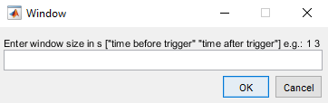

Plots with behaviour:

*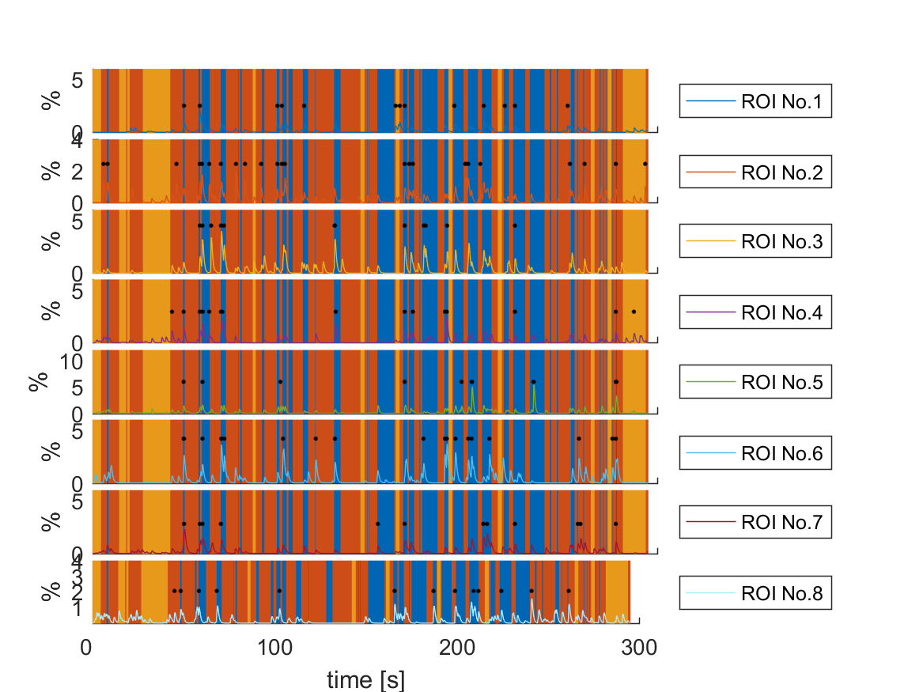*

traces\_behav\_1.png

*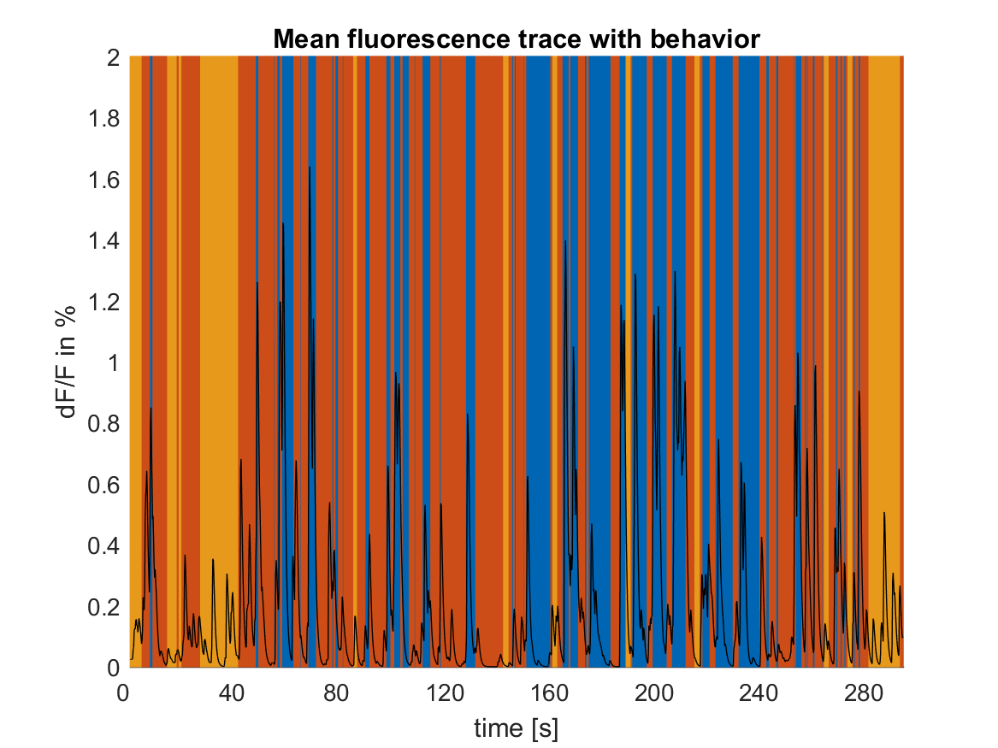*

meanFluobehav.png

*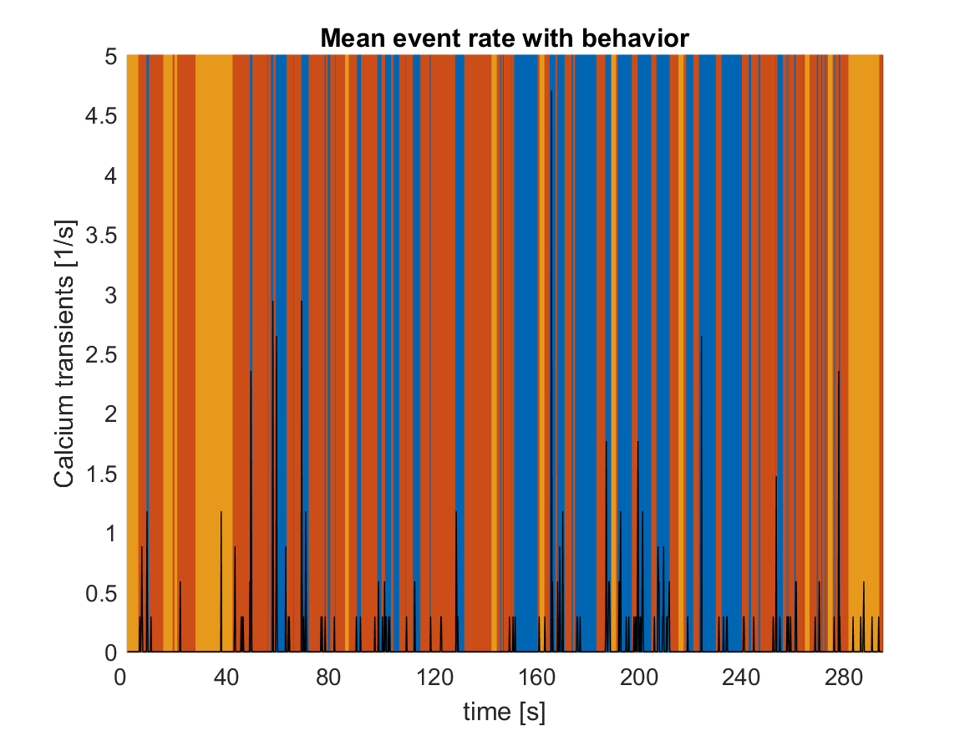*

meanspksbehav.png

*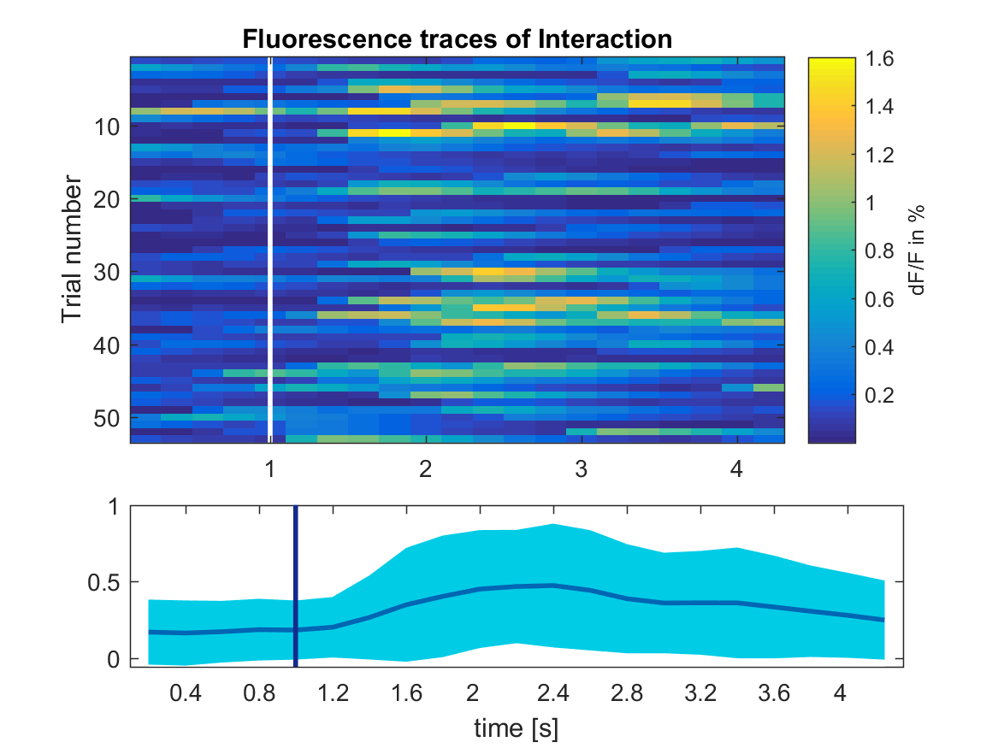*

Fluotrigbehav\_1.png

#### Optional: Save Video

*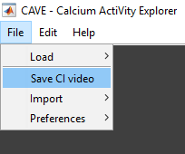*

If you wish, you can export a processed version of the calcium imaging video as AVI-file (6). You have the option between exporting the original video in your chosen contrast and brightness settings or the delta F/F video.

#### Importing Trigger

*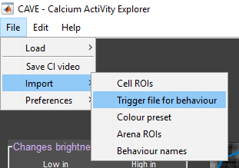*

If you used a trigger during your experiment, you can import this by selecting File → Import →Trigger file for behaviour. At this stage of the Software the trigger file has to be a MAT-file and consist of two columns: timestamp in ms, and trigger value (see below).

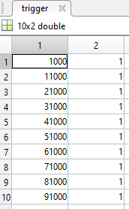

## II Workflow to Process the Behavioural Video

#### C:\Users\Asspen\Documents\PhD\MatlabGUI\help\behavload.PNGLoading Behavioural Video

You can load your behavioural video, which should be in MP4 format, by selecting File → Load → Behavioural video. The directory will already be the same as the directory the calcium imaging video is from. The video will be loaded in a way that it matches the frame rate of the calcium imaging video. If the frame rate of the behavioural video is higher, it will only read every nth frame to match the frame rate from the calcium imaging video. If the frame rate of the calcium imaging video is higher, then it will duplicate the same frame until a new frame of the behavioural video is available.

In case you do not have an automated system that starts and stops both videos at the same time, you might lose some frames. Therefore a message box will inform you about the frames that were cut off (below). Positive number means the behavioural video was shortened, negative number means the calcium imaging video was shortened. If the calcium imaging video was shortened you will be notified to re-plot your calcium traces.

*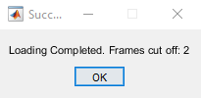*

#### Crop and Down Sample Video

*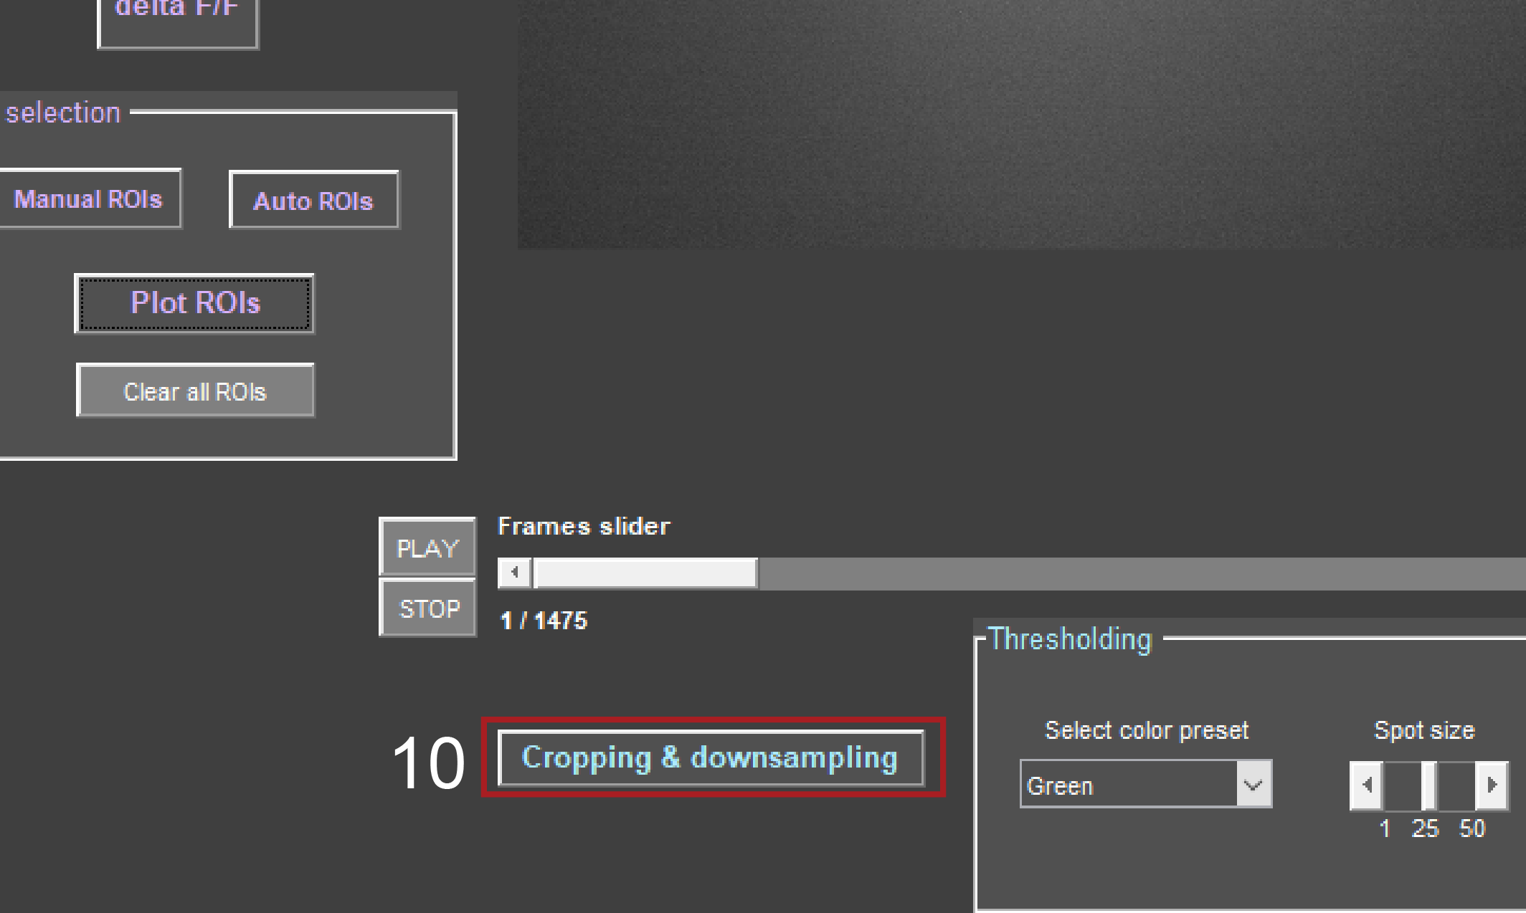*

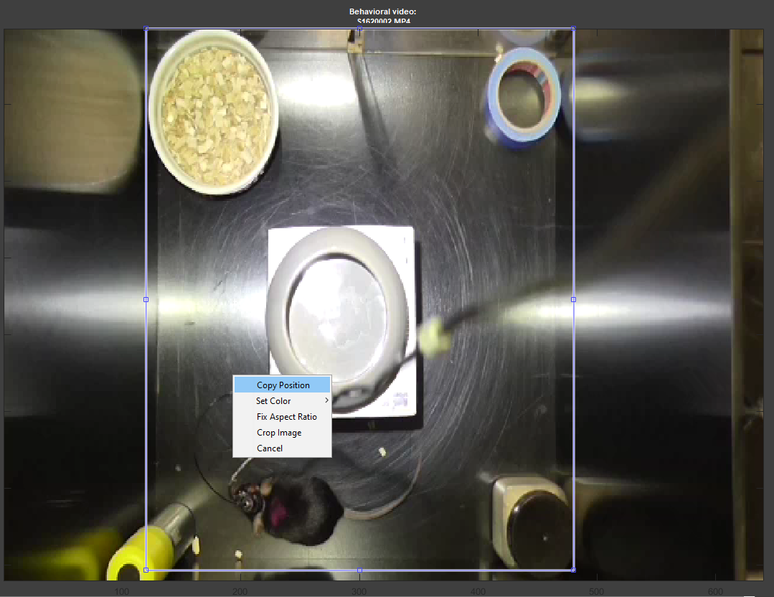Crop the video (10) by defining the testing area, right-click, and copy position. The import wizard will guide you through the next step of importing the location of your defined ROI (below). Click ‘Next’ and then ‘Finish’.

*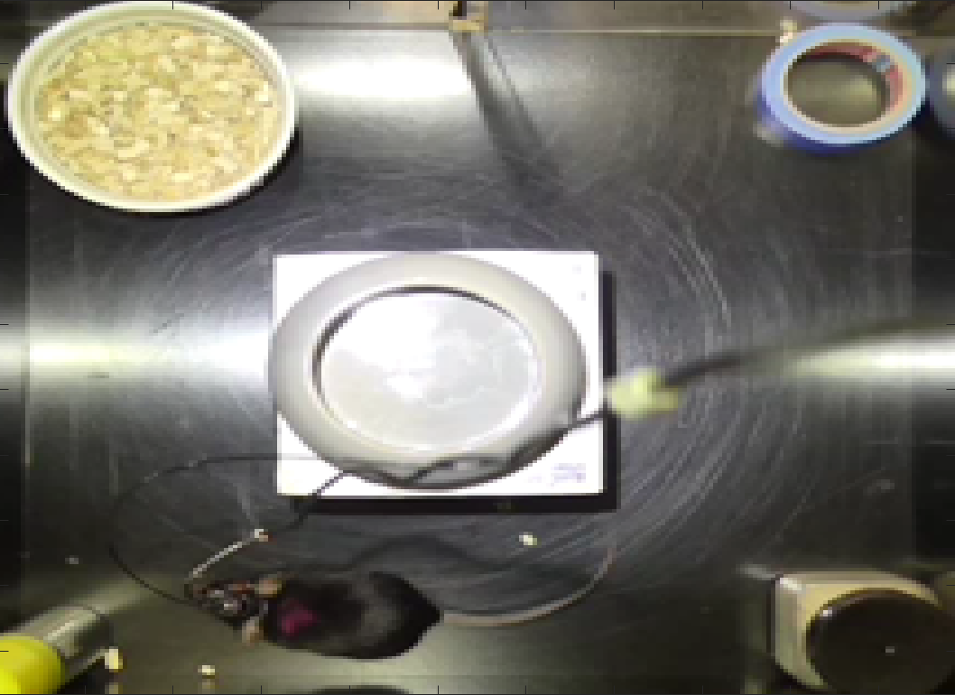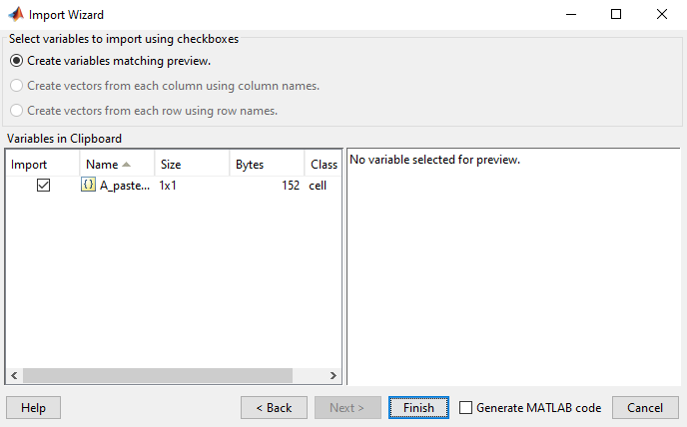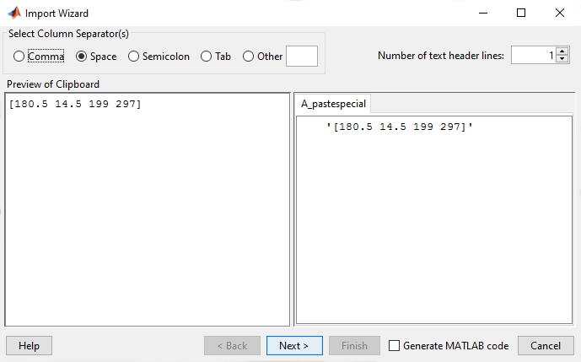*

Result from cropping and down sampling.

The resulting video is down sampled to 60% and saved as progress so it can be loaded if you open the same file again (**yourfilename**\_converted.mat).

#### Optional: Define Mask for Tracking Animal

*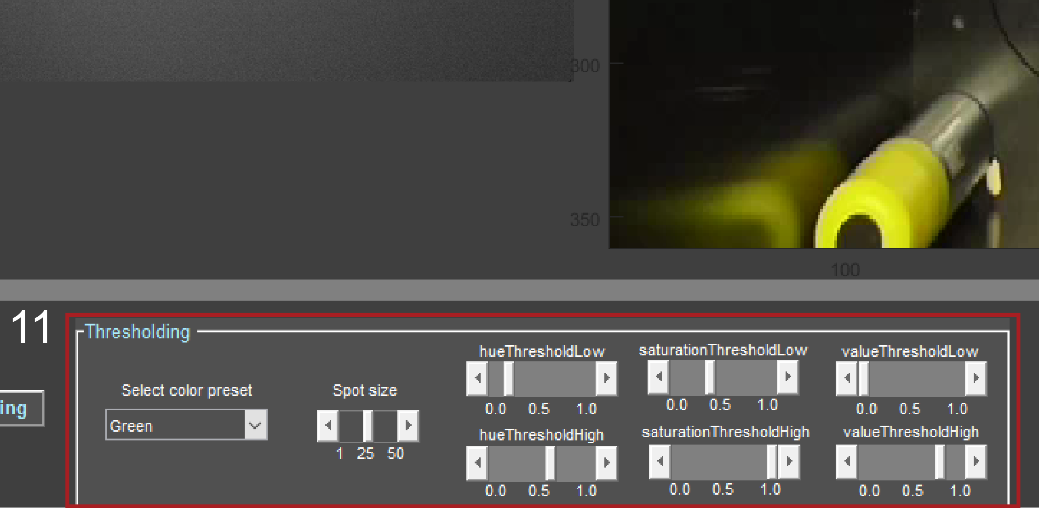*

To track the location of the animal you must have at least on coloured spot on your animal. To track orientation of the animal you need two spots, naturally. In order to create a mask of a colour, you need to adjust the hue, saturation, and value thresholds (11). In the drop-down menu (‘Select color preset’) you already have a selection of different colours where those values are predefined. The choices are green, pink, yellow, and blue. To select a pre-set, click on the respective colour in the drop-down menu. You will see a preview of the spot like below for green and pink.

*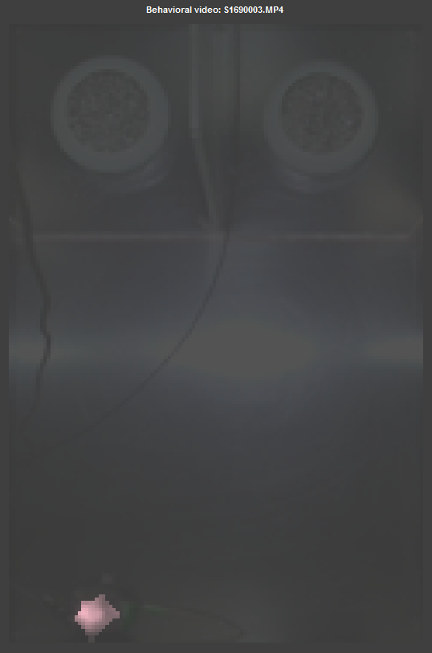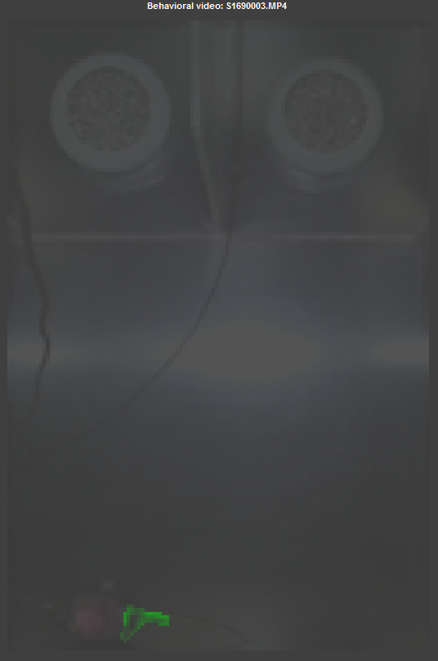*

If the spot cannot be detected with the current mask, it will be displayed in the video (‘Animal out of bounds.’). This could be for multiple reasons, the animal is not visible, the spot is too small or the values for the different thresholds are wrong. If the animal is out of bounds you will still be able to determine that by the faint image of the current frame. If the spot is too small, you can adjust the cut off size with the slider ‘Spot size’. This will adjust the threshold at which small objects are removed to avoid noise. If the thresholds are wrong, try selecting a pre-set; otherwise adjust the different thresholds until you see a coloured mask like above.

To make it easier for long experiments that are repeated every day, there is the option to import a pre-set. Pre-sets are saved after you ‘Preview the spot’ (chapter 4) into the MAT-file presetA/presetP.mat for the anterior or posterior spot respectively. If you have only one spot on your animal, it counts as the anterior spot. By selecting File → Import → Colour preset, you can select settings you took in a previous experiment. If you have both pre-sets saved, a pop-up will ask you, which one you would like to import (see below). If you had only one spot it will automatically load the pre-set as anterior spot.

*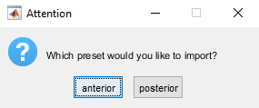*

#### Optional: Preview and Save Tracking

*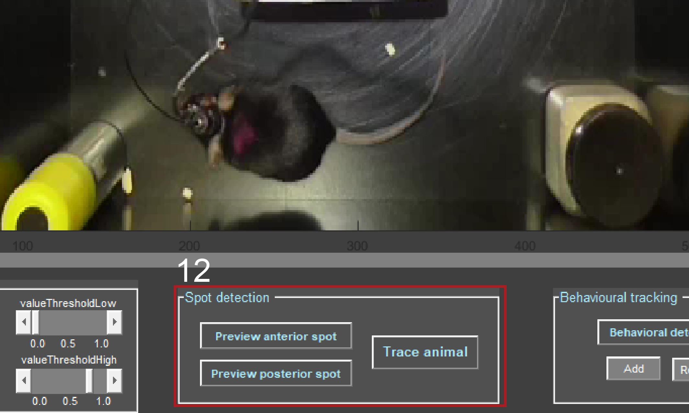*

*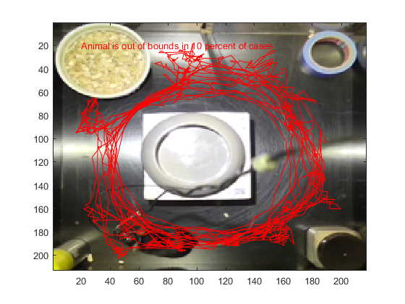*Once you determined your coloured mask, you can preview the tracking of the animal by pressing ‘Preview anterior/posterior spot’ (12). It will track the animal in the colour of the spot you selected and display how often the animal cannot be tracked in percent (red text). Then you adjust the thresholds and preview again or proceed with the next spot. If both spots are tracked, proceed to tracing the animal. By pushing ‘Trace animal’ a new folder will be created in your origin folder with the name location. First the tracing is saved as PNG (**yourfilename**\_mouse\_trace.png). In order to save the table (containing distance travelled, velocity, no movement of animal in percent, and animal out of view in percent) you need to define the scale to convert pixel to centimetres. To do so, you draw a line of a distance you know the length of in the animal arena, right-click onto the line, push ‘Copy Position’ and close the window. Then you follow the wizard and click ‘Next’ and ‘Finish’. Afterwards you type in the length in cm (see below).

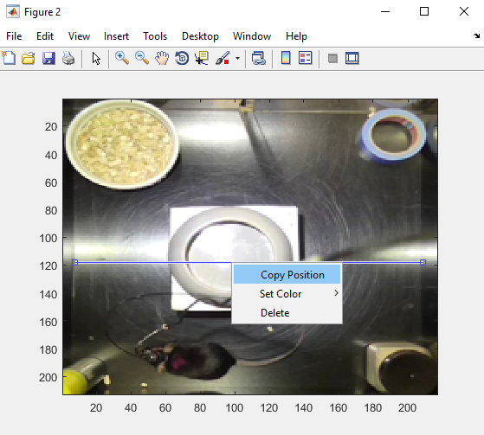

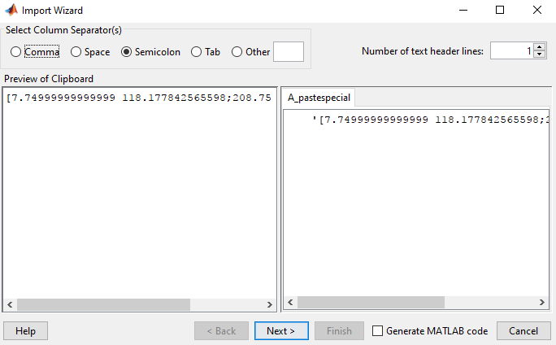

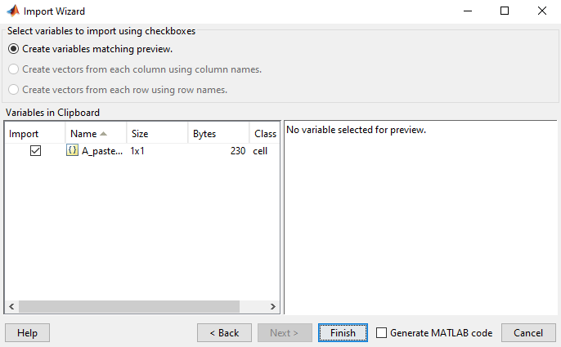

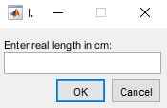

This scale will be saved in Preferences and will be remembered until you change it in File → Preferences → Change animal arena scale. The table is saved as EXCEL file in the folder location as **yourfilename**\_behavior.xls.

*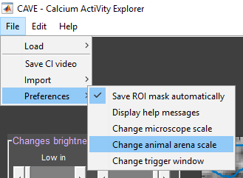*

#### C:\Users\Asspen\Documents\PhD\MatlabGUI\help\overviewvidS1_12.pngOptional: Plot Locations Correlating with Cell Activity

By pressing ‘Trace animal’ after tracing the animal you have to more options: defining ROIs and correlating location with cell activity. First, you will be asked if you want to define ROIs (see below). If you click ‘Yes’ you will be asked, how many. Then you will draw one ROI after another and name them.The algorithm will then calculate the amount of time the animal spent in each ROI in percent. The results are saved in a table in the *location* folder (***yourfilename***\_compartmentsxls). And the mask will be saved in your origin folder, which you can load it in the next session with your animal (tracingROIs\_***yourfilename***.mat) by selecting *File* → *Import* → *Arena ROIs*.

*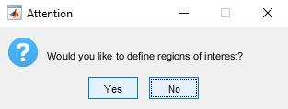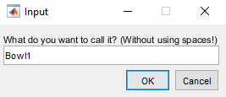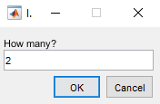*

Second, you have the option of correlating location with the calcium traces. First, the question whether the animal ever leaves the testing area pops up in case it was not possible to track the animal 100% of the time. If you choose ‘Yes’ it will be assumed that in the cases where the animal was not visible stayed at the previous location. If you choose ‘No’ the times the animal could not be tracked is noted in red text in the figure in percent.

Finally, the program will correlate the cell activity found in the calcium imaging video with the location of the animal. It plots every location of the animal at which a spike occurred (black dot in the plots) in a heat map. If you had two spots on the animal, it additionally plots the direction the animal was heading in. Below are two examples. The plots are saved in the folder location in your origin folder (**yourfilename**\_ROI**number**\_trace.png). Additionally, a MAT-file containing the positions of the mouse for each ROI as logical masks and the timestamps of the detected spike from the calcium traces are saved into location (ROIposition\_**yourfilename**.mat).

*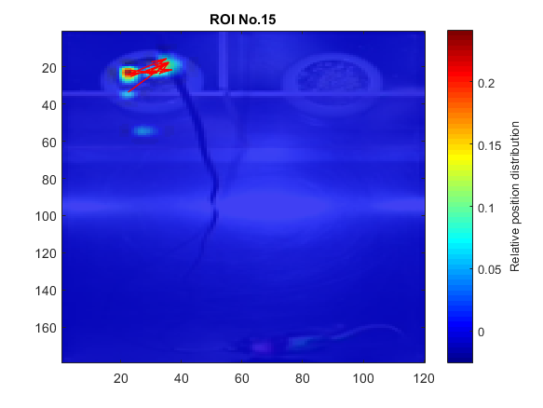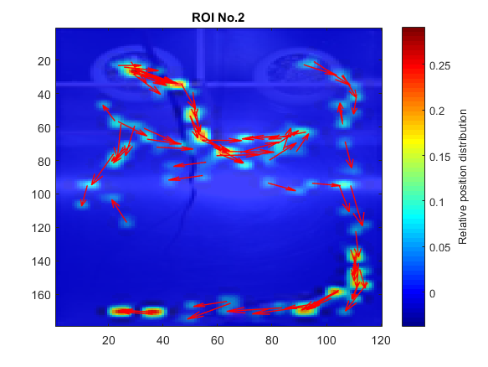*

#### Behavioural Detection

*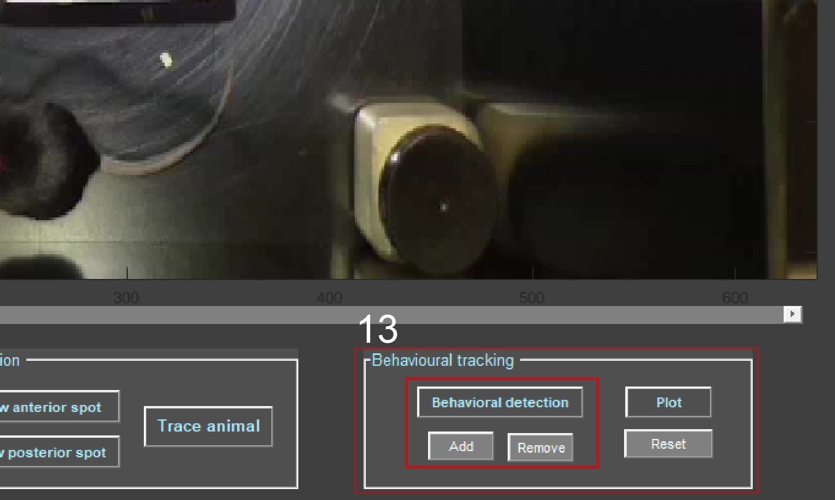*

You can track up to 8 behaviours in the behavioural tracking. You can add behaviours by pushing ‘Add’ and remove by pushing ‘Remove’ (13). Once you defined at least two behaviours you can use the ‘Behavioural detection’. Now you can go to any frame and click the ‘Behavioural detection’ button and select one of your behaviours from a list, to start the definition (see below). The algorithm works such that there is no frame where there is no behaviour, which means, one behaviour is on-going until another behaviour starts. You can reset all behaviour names and registered frames anytime by pushing ‘Reset’.

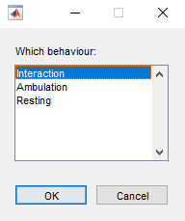

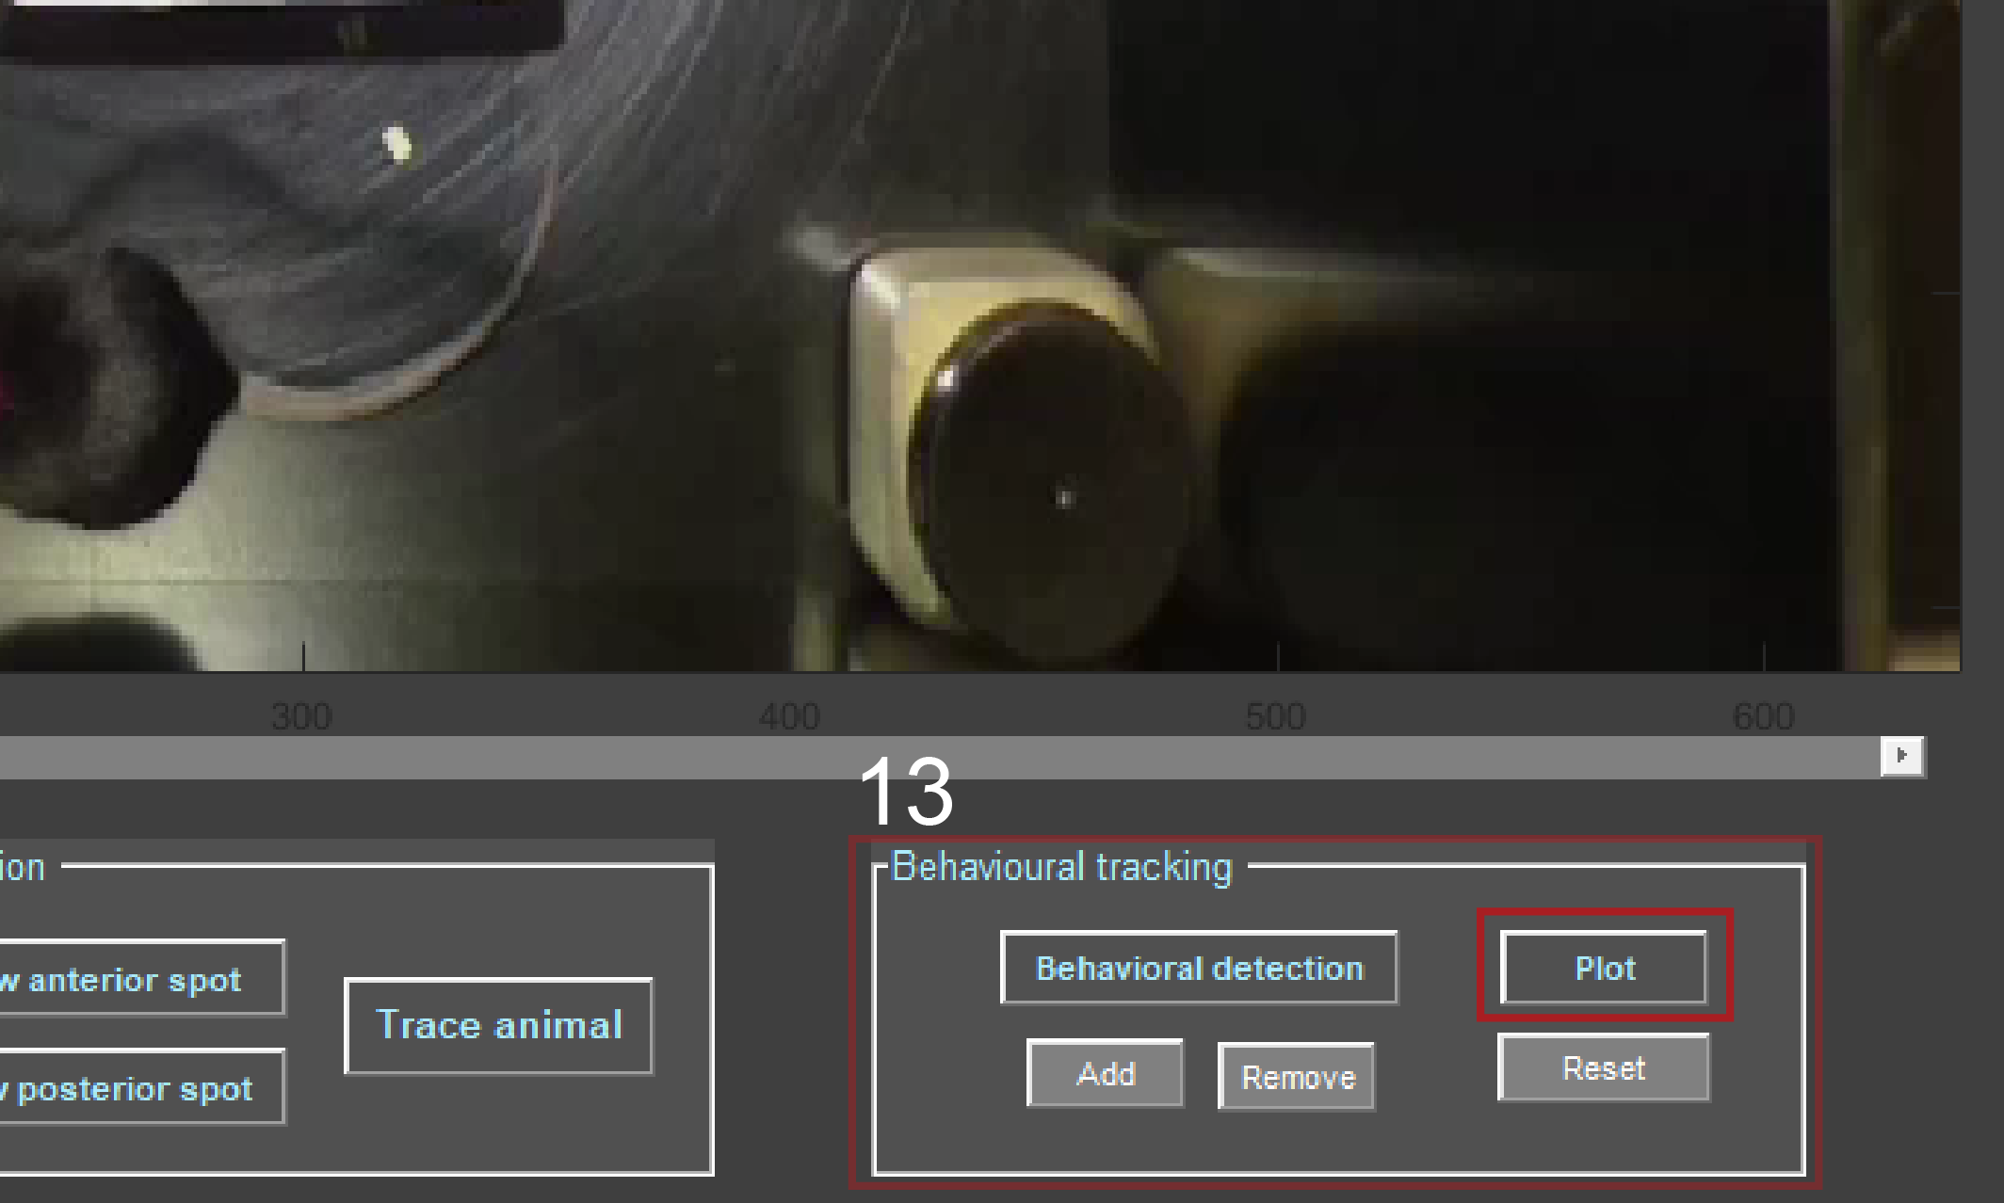

Once you defined the behaviour to your satisfaction you can plot the resulting bar graph by pushing ‘Plot’ (13). The plot is saved as PNG in your origin folder (**yourfilename**\_mouse\_behavior.png).

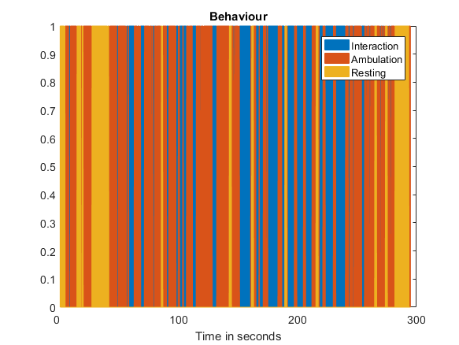

Furthermore a MAT-filecontaining the number of behaviours you defined, their names, binary matrix when each behaviour was defined, binary files of the bars representing each behaviour, as well as timestamps and duration of behaviours (Behavior\_**yourfilename**.mat). This file is imported when you load the same version again or alternatively, you can import this file to another session by selecting File → Import → Behaviour names.

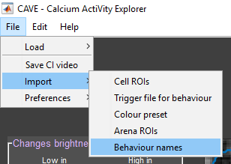

## III Advanced

#### Setting Parameters

To obtain the best possible results for your individual data it might be best, to tweak some of the constants used in this software. All constants used are saved in the Matlab script *SetParams.m*.

The following parameters are contained in *SetParams.m* and most can be changed as needed:

***Pre*-processing:**

*dsw*: minimum width at which down sampling of the calcium imaging video is performed. Default: 100 pixels.

*dsr*: down sampling rate for calcium imaging video. Default: 0.4 = reduction to 40%.

*blur*: blur used for simplified flat field correction. Default: 0.08 = blur of 8%.

**Dust removal:**

*dustr*: radius of the disk structure surrounding the dust ROI to obtain the neighbourhood mean for filling the ROI. Default: 8 pixels.

**Alignment:**

*wienerp*: neighbourhood of m-by-n to estimate local image mean with wiener2 filter to enhance features of ROI defined for alignment. Default: [6 6].

*usfac*: upsampling factor images will be registered to within 1/usfac of a pixel during subpixel image registration. Default: 100.

*LClevels*: the number of levels for multi-resolution execution in the Lucas Kanade alignment algorithm. Default: 2.

*LCiter*: the number of iterations of the Lucas Kanade alignment algorithm. Default: 5.

**Delta F/F calculation:**

*dbutterd*: value for designing butterworth filter. Default: 4. *Value is not used in the standard software. You have to uncomment the temporal filter section in* deltaFF.m*.*

*dbutterd2:* second value for designing butterworth filter. Default: 0.5. *Value is not used in the standard software. You have to uncomment the temporal filter section in* deltaFF.m*.*

*dgaussh:* Gaussian low-pass filter of size 5 (default).

*Dgausss:* Gaussian low-pass filter with standard deviation 5 (default).

**PCA/ICA:**

*pigausss:* 2-D Gaussian smoothing kernel with standard deviation of 1.5 (default).

*pisaa:* smallest acceptable area for results from ICA aka smallest dimension of a cell. Default: 30 pixels.

*pibwP:* removes all connected components that have fewer than 0.8 (default) pixels from the binary image.

*picsize:* largest acceptable area for results from ICA aka largest dimension of a cell. Default: 300.

*pinroT:* deletes objects which roundness metric is smaller than 0.6 (default).

*piolO:* deletes objects which spatially overlap more than 30 (default) = 30%.

**ROI plotting:**

*neuF*: neuropil correction factor. Default: 0.7.

*spkthrs*: threshold for detecting spikes from deconvoluted calcium traces. This value represents only the factor of the standard deviation of the calcium trace as in spkthrs\*std(signal). Default: 2.

*ROIdist*: maximum distance between the centres of two ROIs at which correlation of the calcium traces of those ROIs is measured. Default: 8 pixels.

*sigcorr*: minimum correlation at which two ROIs are assumed to be one. Default: 0.8.

*chg*: minimum value for fluorescence change, if the absolute maximum of a calcium trace is below this value, the ROI is deleted. Default: 0.8 = 0.8% fluorescence change.

**Behavioural video:**

*bdsr*: down sampling rate for behavioural video. Default: 0.6 = reduction to 60%.

*bdistmin*: minimum pixel distance the animal has to move to be considered moving. Default: 1 pixel.

*bdistmax*: maximum pixel distance the ‘animal’ can move to be considered moving, this should prevent misrepresentations of the animal location, where the location suddenly jumps. Default: 40 pixels.

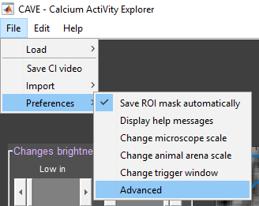For simplification the most important of these values can be changed (see below) in *File* → *Preferences* → *Advanced*. Any changes you make will be saved in *Preferences*.

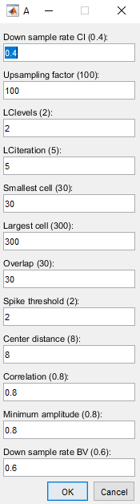

## IV Troubleshooting

### Possible Problems:

*My calcium imaging video will not load/load correctly:*

Is your video a TIFF-file that is either one stack or multiple images? Is the TIFF-file in its own separate folder from TIFF-files of other measurements? Is the TIFF-file saved in 8-bit or 16-bit depth?

*After pre-processing I still find glitches in the video:*

The algorithm is only prepared for glitches that last single frames. If a glitch lasts multiple frames, the code cannot handle it.

*After pre-processing my video is far to pixelated:*

Adjust the *dsr* value in *SetParams.m* to a higher value to alter the down sampling rate.

*After alignment my video is still shaky:*

If you tried the Lucas Kanade algorithm with the ‘Area’ option, try different regions to see which works best. Otherwise try to increase the *LClevels* or *LCiter* in *SetParams.m*. If you tried the Subpixel registration algorithm, try to change the *usfac* in *SetParams.m*. Sometimes it might help to align multiple times, but note that the ‘Reset’ button can only reset to the version before and not the original version.

*I cannot see any cells in the video after the delta F/F calculation:*

Good chances are, there are none. If you also cannot see any cell like structures in the maximum intensity projection (MIP), there might be no cells. However, try the data with a different software.

*The ‘Auto ROI’ cannot identify cells or only very few:*

The activity might be too sparse for the ICA to find it. You should manually scroll through the video and select ROIs manually.

*The ‘Auto RIO’ is not finding all cells that are visible in the maximum intensity projection:*

Increase your estimate of number of cells. Otherwise, try adjusting the parameters of smallest cell (*pisaa*) and/or largest cell (*picsize*) in *SetParams.m*.

*The ‘Auto ROI’ is segmenting cells:*

Decrease your estimate of number of cells.

*When I scroll through the video a new figure opens with the ROI mask:*

We are still working on removing this bug, sorry for the inconvenience.

*After plotting the calcium traces some values are off the chart below zero:*

There seems to be some drift or sudden shift in brightness in the raw video. Try uncommenting the global temporal filter in *flatFieldCorrection.m* and edit the video starting from the raw video.

*I can see spikes in my calcium traces that are not detected/do not show a black dot:*

Adjust the spike threshold spkthrs in SetParams.m.

*My trigger file is not loaded/ loaded correctly:*

This feature is work in progress, if your trigger file is not a MAT-file, and not a matrix containing of 2 columns, the first for timestamps of the trigger and the second for the trigger value, then it will not work.

*My behavioural video will not load:*

Is your video a MP4-file?

*My animal appears pixelated in the behavioural video:*

Increase the *bdsr* value in *SetParams.m* to adjust the down sampling rate of the video.

*My animal cannot be identified/the colour mask does not work:*

Have you marked the animal with a distinct colour like green, yellow, blue or pink? If so, adjust the spot size or the thresholds. Most commonly, the lower saturation threshold needs to be reduced for the mask to show. If you did not mark the animal, you cannot track it with the thresholding.

*After the preview of the spot, it shows me a high number of absence and the trace shows abrupt changes:*

You need to adjust the thresholds to adjust the mask. Scroll through the video to control for misses in the mask.

05/01/2018 Jennifer Tegtmeier CAVE.m